Movie Script Analysis

Mikolaj Wieczorek and Marshal Will

12/12/2019

# Motivation

We wanted to look at movie scripts and see if there were any common traits associated with movies. Because of this we decided to do text mining on Movie Scripts and analyze text features.

# Executive summary

By looking at movie scripts we have found a number of interesting conclusions based on what we found. We found that one of the largest emotions that are found in movies is trust. We also found that common genre movies do tend to cluster around each other like for example kids’ movies. We expected there would be more clustering around genre but, it wasn’t as significant as we expected.

# Methods used:

Clustering (hclust, agnes, and kmeans)

Association Rules

Sentiment Analysis

Frequency Plots

## Upload Movies

path_85 = "~/OneDrive - MNSCU/myGithub/Unsupervised_Learning/Movie-Script-Unsupervised-Learning-Methods-Analyses/85_movies"  
dir_85 = DirSource(paste(path_85, sep=""), encoding = "UTF-8")  
corpus_85 = Corpus(dir_85)  
head(summary(corpus_85))

## Length Class Mode  
## 500-Days-of-Summer.txt 2 PlainTextDocument list  
## A-Few-Good-Men.txt 2 PlainTextDocument list  
## A-Prayer-Before-Dawn.txt 2 PlainTextDocument list  
## Abyss,-The.txt 2 PlainTextDocument list  
## Alien.txt 2 PlainTextDocument list  
## American-Outlaws.txt 2 PlainTextDocument list

tail(summary(corpus_85))

## Length Class Mode  
## Tomorrow-Never-Dies.txt 2 PlainTextDocument list  
## Vanilla-Sky.txt 2 PlainTextDocument list  
## Visitor,-The.txt 2 PlainTextDocument list  
## War-of-the-Worlds.txt 2 PlainTextDocument list  
## When-a-Stranger-Calls.txt 2 PlainTextDocument list  
## X-Files-Fight-the-Future,-The.txt 2 PlainTextDocument list

ndocs <- length(corpus_85)  
# ignore extremely rare words i.e. terms that appear in less then 1% of the documents  
minTermFreq <- ndocs * 0.15  
# ignore overly common words i.e. terms that appear in more than 50% of the documents  
maxTermFreq <- ndocs * .5  
dtm_85 = DocumentTermMatrix(corpus_85,  
 control = list(  
 stopwords = T,   
 wordLengths=c(4, 15),  
 removePunctuation = T,  
 removeNumbers = T,  
 #stemming = T,  
 #removeWords("bateman"),  
 bounds = list(global = c(minTermFreq, maxTermFreq))  
 ))

#dtm <- dtm[, names(head(sort(colSums(as.matrix(dtm))), 400))]  
#dtm <- dtm[, names(sort(colSums(as.matrix(dtm))))]  
dtm.matrix_85 = as.matrix(dtm_85)  
dim(dtm.matrix_85)

## [1] 85 3182

We did a word cloud of the amount of words used in all movies. We can see dances, bridge and frank were one of the most common ones. This is generated by setting the minimum and maximum

## Clustering

##### Preparing for clustering ######

#Clustering words  
tdm_85 = t(dtm_85)  
#Removing sparse terms  
tdm_no_sparse_85 = removeSparseTerms(tdm_85, sparse = .99)  
#Cluster  
tdm.mat_85 <- as.matrix(tdm_no_sparse_85)  
#First 20 most frequent words  
word.freq = sort(rowSums(tdm.mat_85), decreasing = T)  
barplot(word.freq[1:20], cex.names = .8)

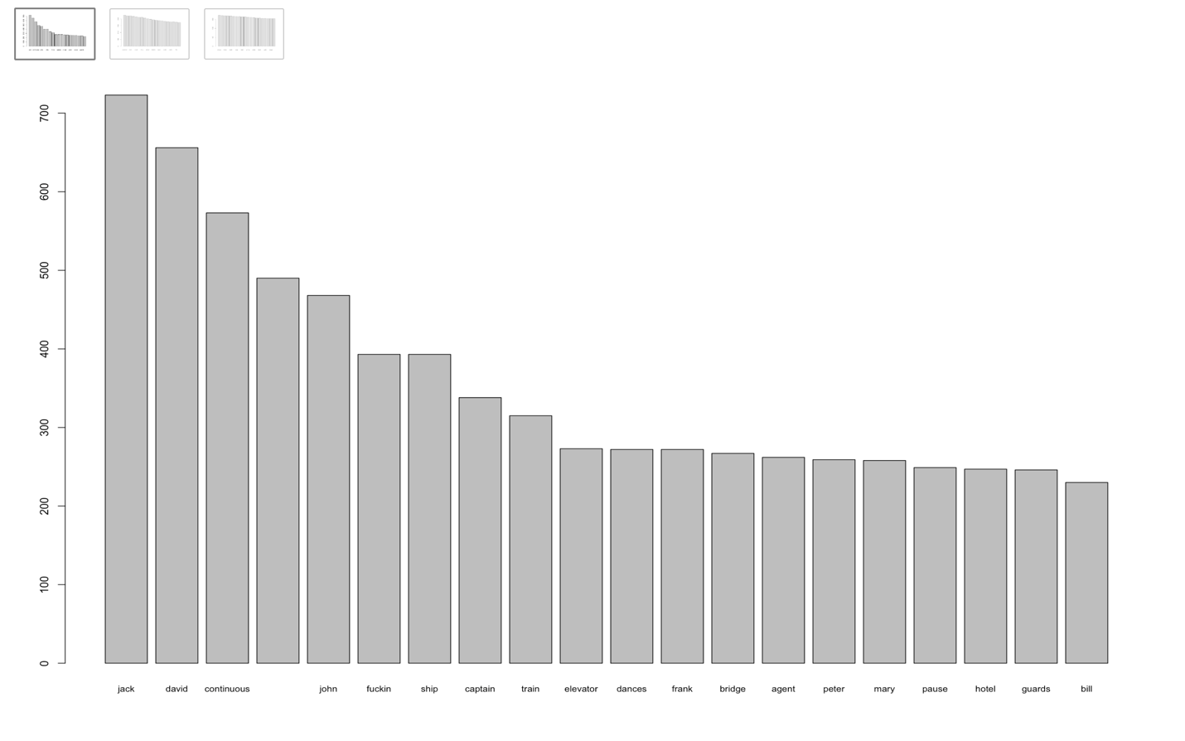

#Next 20 most frequent words  
barplot(word.freq[21:40], cex.names = .8)

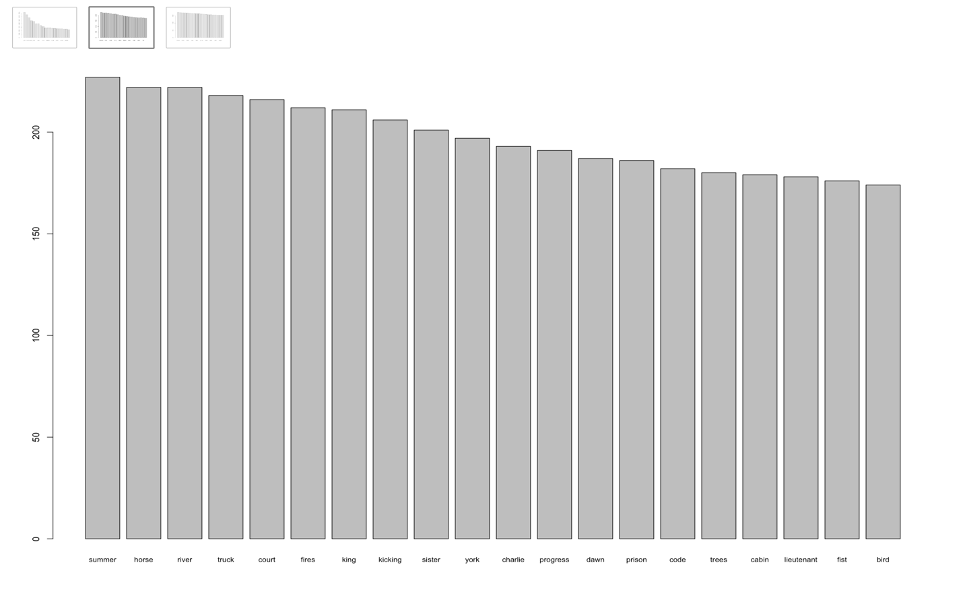

#Next 20 most frequent words  
barplot(word.freq[41:60], cex.names = .8)

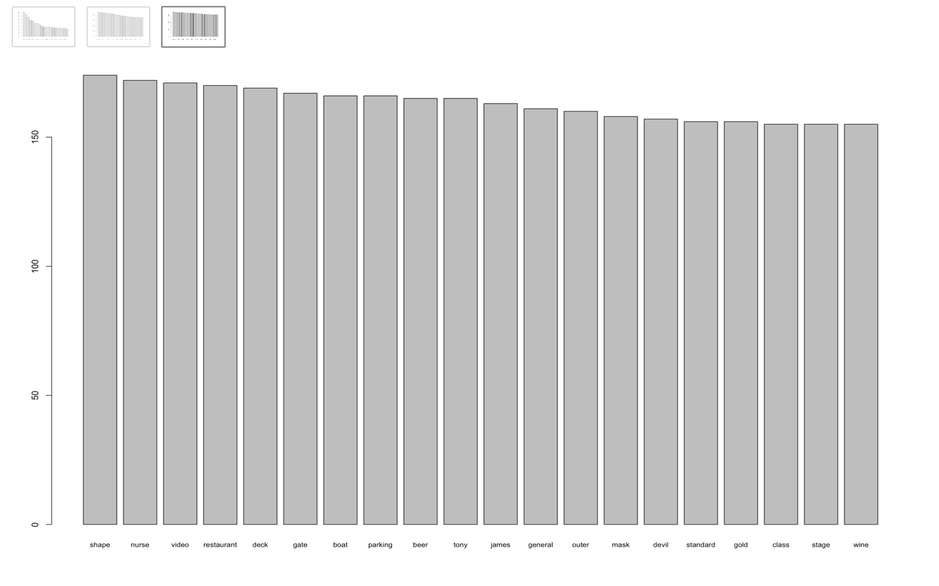

The most common words appear to be:

**fuckin, ship, captain, train, elevator, dances, bridge, agent, hotel, guards,**   
summer, horse, river, truck, court, fires, king, kicking, sister, york,  
progress, dawn, prison, trees, cabin, lieutenant, bird

We are not considering names or words that relate to directions for actors in the movie script; there are still some left out even after cleaning all the 85 scripts in python to generate “spoken words”

### Clustering Words

#Clustering words: words as terms and movies as documents: T-D  
clust.tdm.matrix_85 = as.matrix(tdm_85)  
clust.tdm.matrix_85[clust.tdm.matrix_85>1] = 1

#Using Agnes  
tdm.agnes.ward_85 = agnes(clust.tdm.matrix_85, metric = "Jaccard", method = "ward")

#Plotting Agnes cluster  
plot(tdm.agnes.ward_85,cex = 0.7, which.plots = 2)

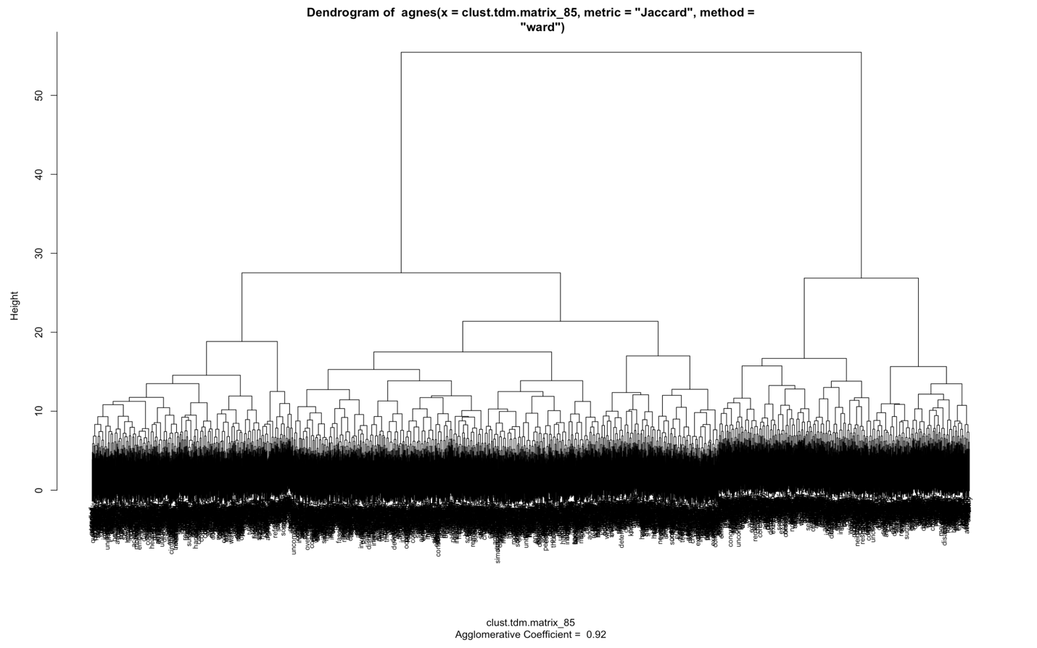

We transformed the words as a document matrix then created an output of the cluster.

#Using hclust  
tdm.movie.dist_85 = dist(clust.tdm.matrix_85, method = "Jaccard")

#Plotting hlust  
tdm.movie.clust_85 = hclust(tdm.movie.dist_85, method = "ward.D")  
plot(tdm.movie.clust_85, cex = .7)

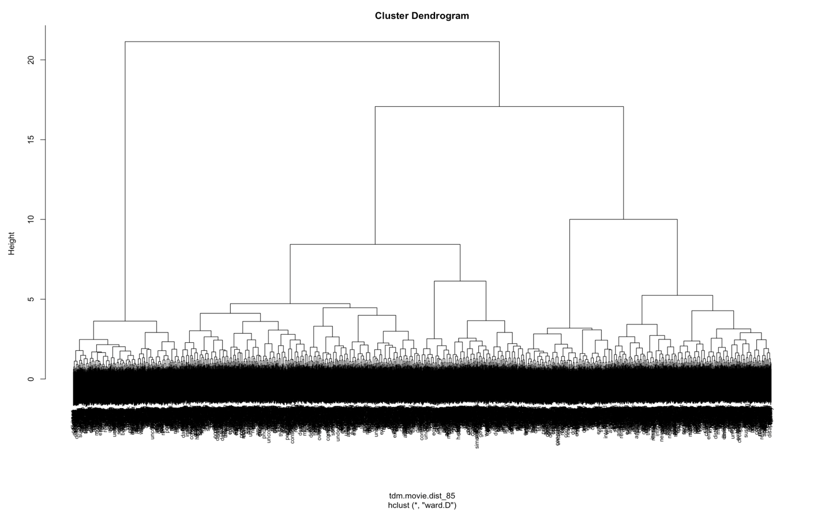

Further we plotted the term document matrix.

words.groups_85 = cutree(tdm.movie.clust_85, k=25)  
table(words.groups_85)

## words.groups_85  
## 1 2 3 4 5 6 7 8 9 10 11 12 13 14 15 16 17 18   
## 106 106 190 134 142 244 101 117 148 81 292 62 62 138 60 121 147 84   
## 19 20 21 22 23 24 25   
## 150 142 107 52 123 179 94

#### K-means

#Optimal number of clusters  
fviz_nbclust(clust.tdm.matrix_85,kmeans,k.max=15,method="silhouette")

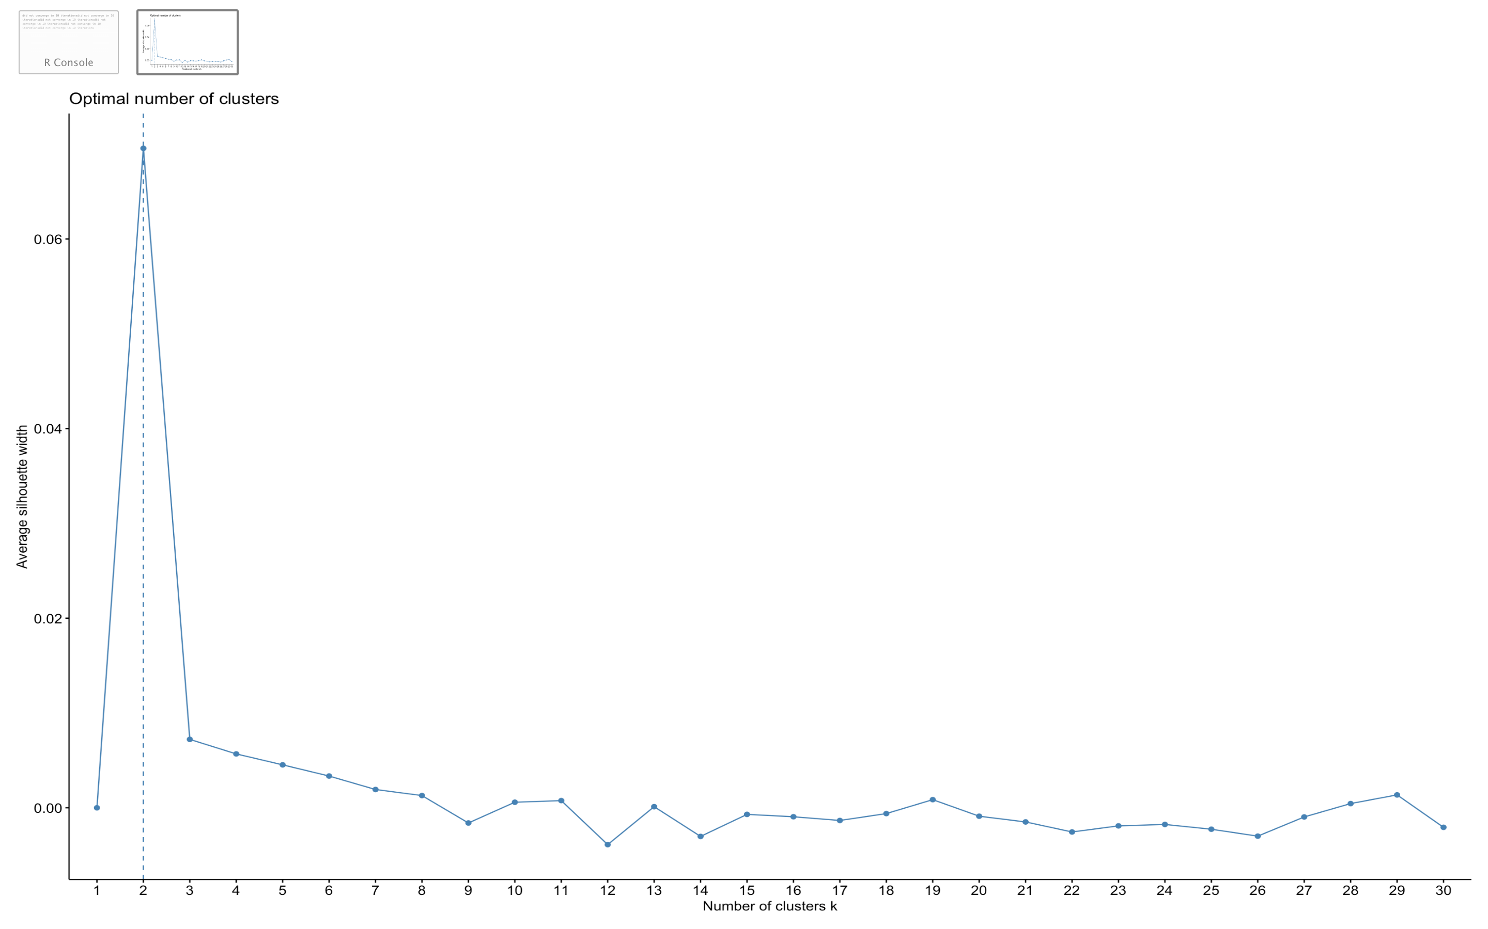

fviz_nbclust(tdm. mat_85,kmeans,k.max=15,method="wss")

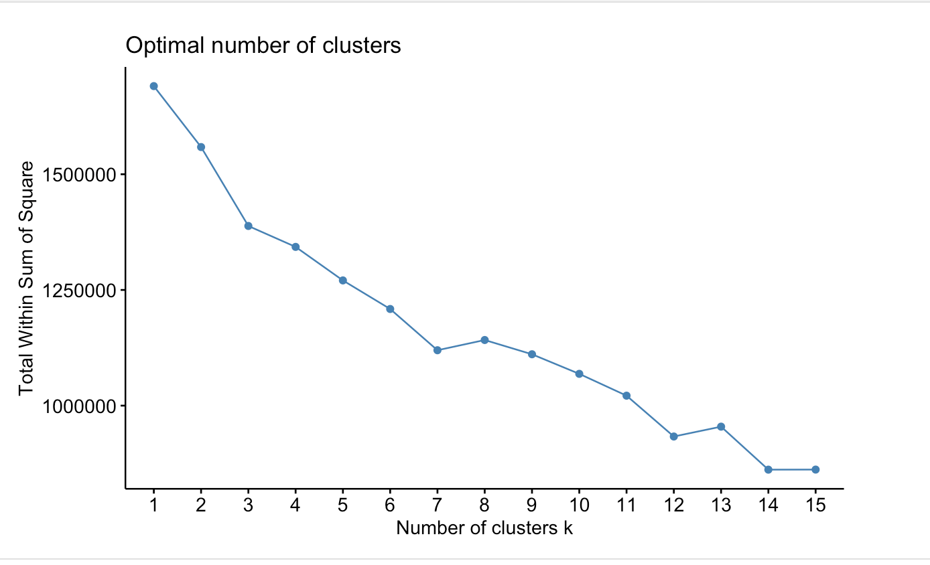

We looked at the optimal amount of clustering to be around 2 k means, any more and the avg. silhouse width gets smaller which is something to be avoided. Up above we can also see that after about 6 k means clusters that the performance tends to be about the same no matter the increase in clustering.

#fviz_nbclust(clust.tdm.matrix_85,kmeans,k.max=15,method = "gap_stat")

shooby_85_words = kmeans(clust.tdm.matrix_85,3)  
table(shooby_85_words$cluster) #,BCGenes$PAM50mRNA)

##   
## 1 2 3   
## 856 1061 1265

fviz_cluster(shooby_85_words,data = clust.tdm.matrix_85)

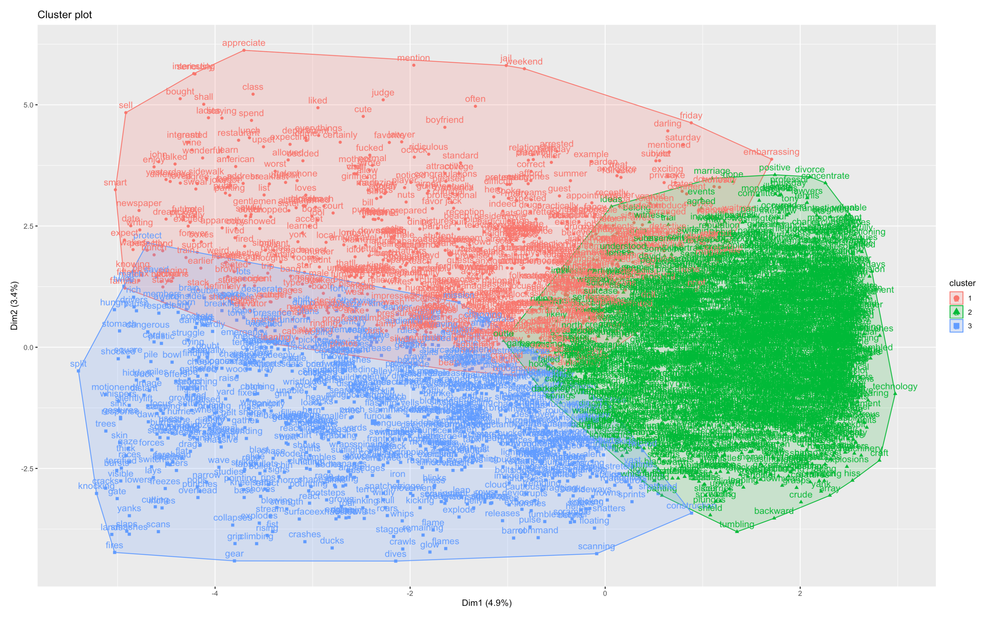

### Clustering Movies

#Clustering movies: movies as documents and words as terms: D-T  
clust.dtm.matrix_85 = dtm.matrix_85  
clust.dtm.matrix_85[clust.dtm.matrix_85>1] = 1  
  
#Clustering words: words as terms and movies as documents: T-D  
clust.tdm.matrix_85 = as.matrix(tdm_85)  
clust.tdm.matrix_85[clust.tdm.matrix_85>1] = 1

#Using Agnes  
dtm.agnes.ward_85 = agnes(clust.dtm.matrix_85, metric = "Jaccard", method = "ward")

We have about 3 clusters based on the dtm matrix from calculating the clusters. For the dtm matrix we can see that a majority of the movie fit int those 3 sections with little overlap.

#Plotting Agnes cluster  
plot(dtm.agnes.ward_85,cex = 0.7, which.plots = 2)

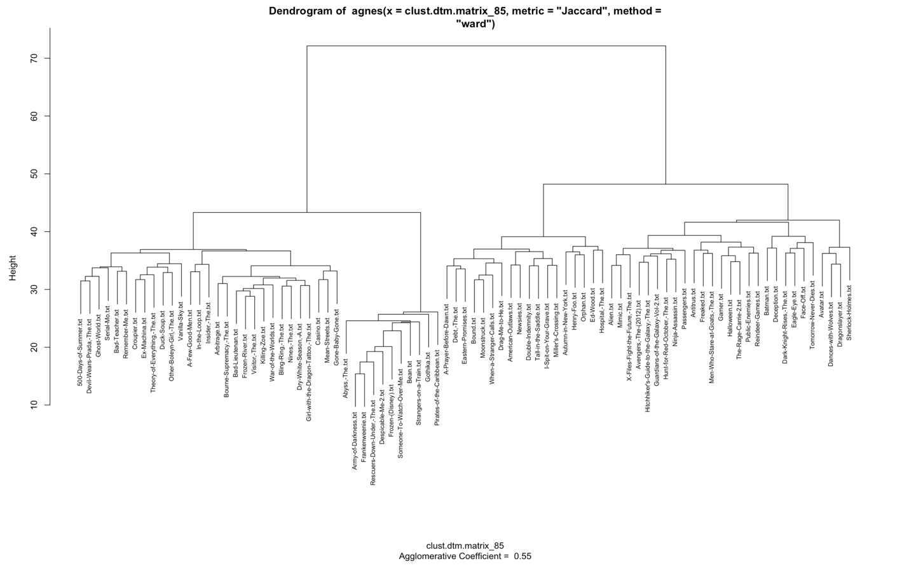

#Using hclust  
dtm.movie.dist_85 = dist(clust.dtm.matrix_85, method = "Jaccard")

#Plotting hlust  
dtm.movie.clust_85 = hclust(dtm.movie.dist_85, method = "ward.D")  
plot(dtm.movie.clust_85, cex = .7)

When we looked hierarchical clustering based on the Jaccard method we got some interesting clusters around kids movies like Frozen and Despicable Me, and Someone to Watch Over me.

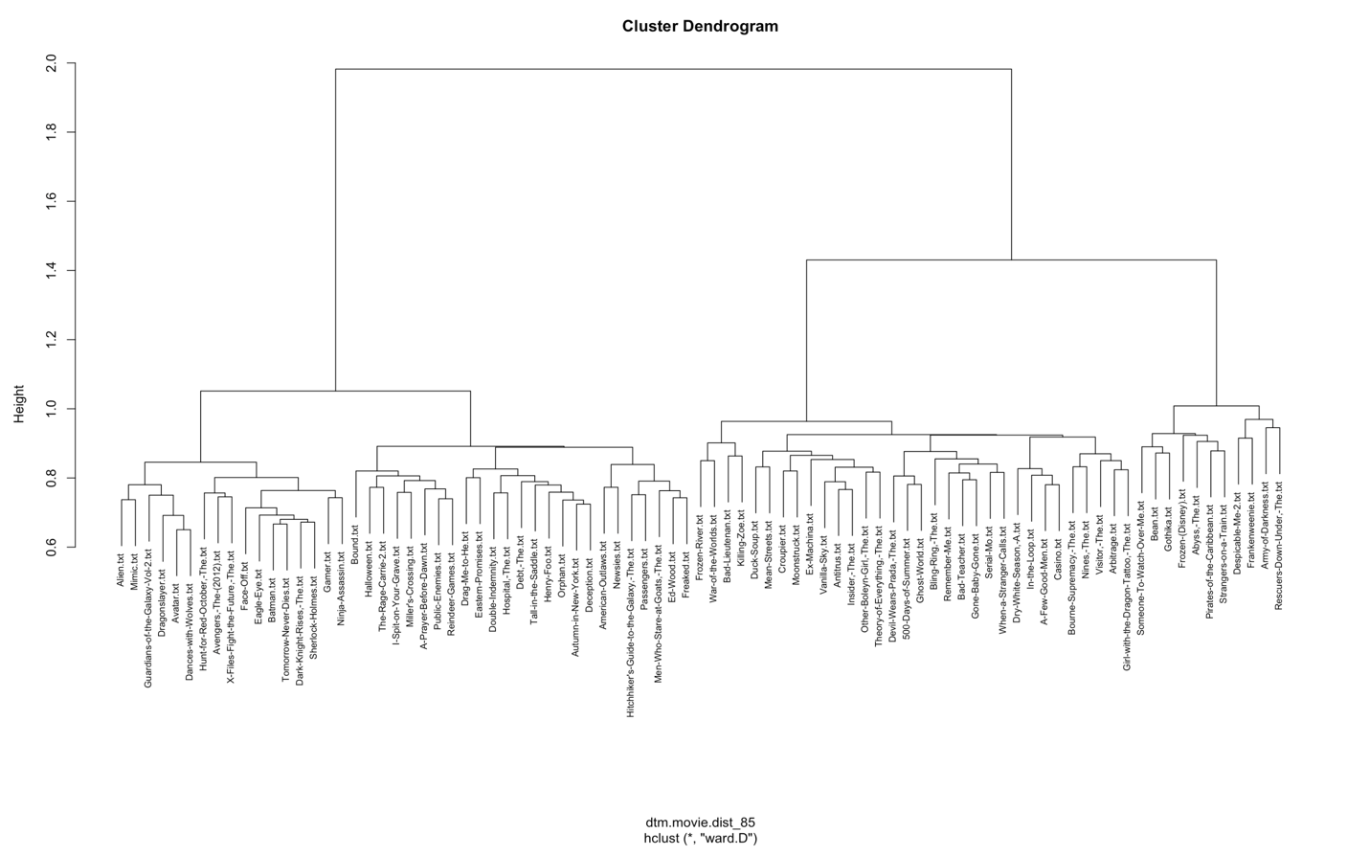

movie.groups_85 = cutree(dtm.movie.clust_85, k=6)  
table(movie.groups_85)

## movie.groups_85  
## 1 2 3 4 5 6   
## 32 25 7 17 2 2

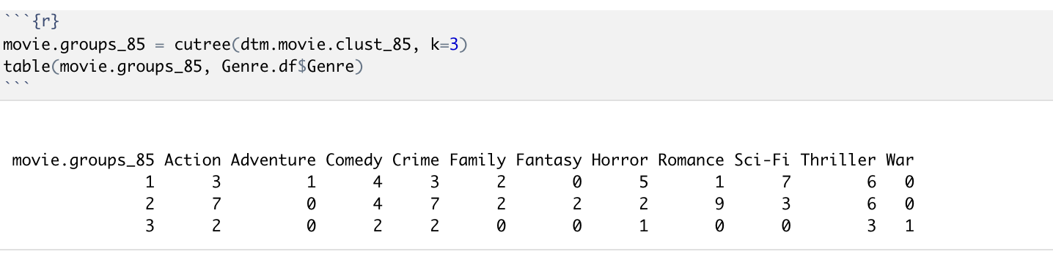

We had cross tabulated the data by genre and we had tried clustering. When we tried clustering around those genres it didn’t yield anything significant or intresting.

#### K-means

#Optimal number of clusters  
fviz_nbclust(clust.dtm. matrix_85,kmeans,k.max=15,method="silhouette")

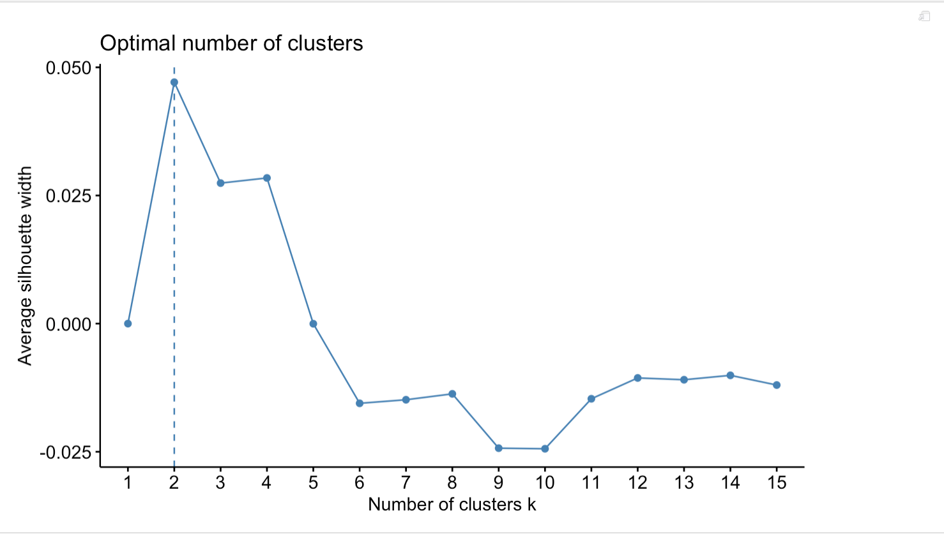

Our optimal width was about 2 as it starts to decrease which means that it performs worse when there are less clusters.

fviz_nbclust(clust.dtm.matrix_85,kmeans,k.max=15,method="wss")

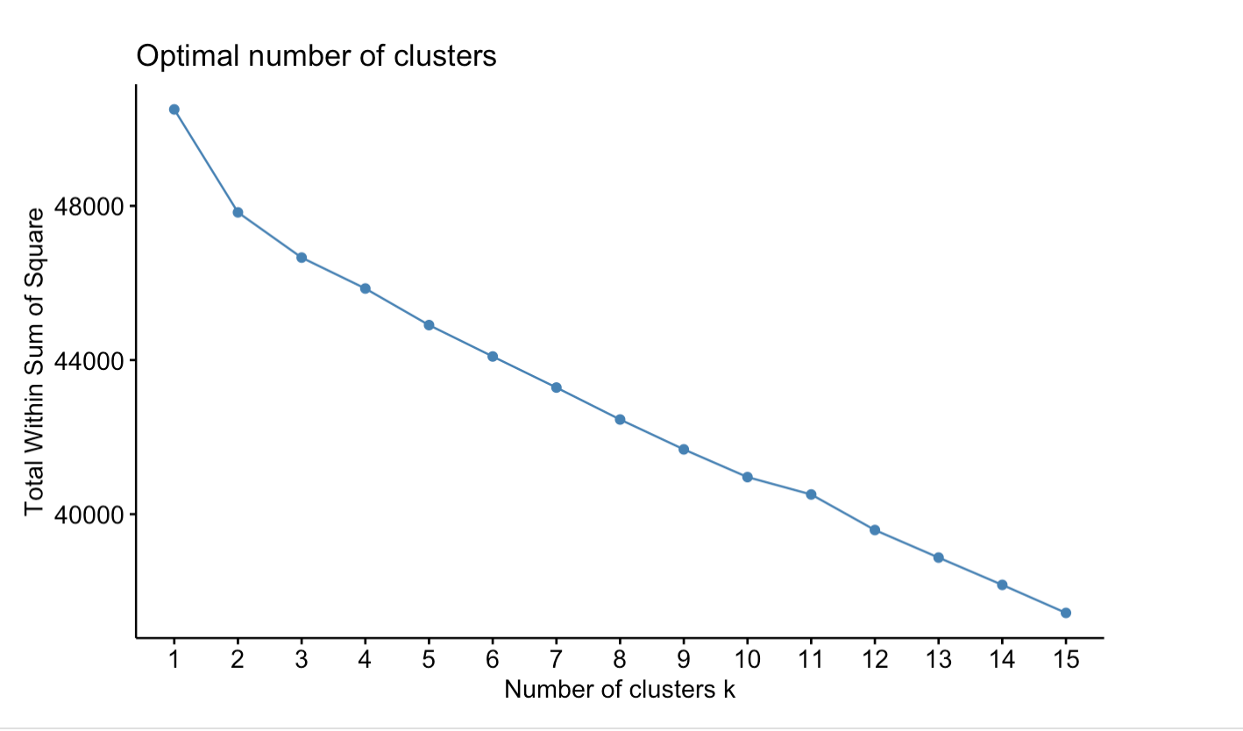

Also our total width sum of square steadily decreases as our number of k clusters increases.

fviz_nbclust(clust.dtm.matrix_85,kmeans,k.max=15,method = "gap_stat")

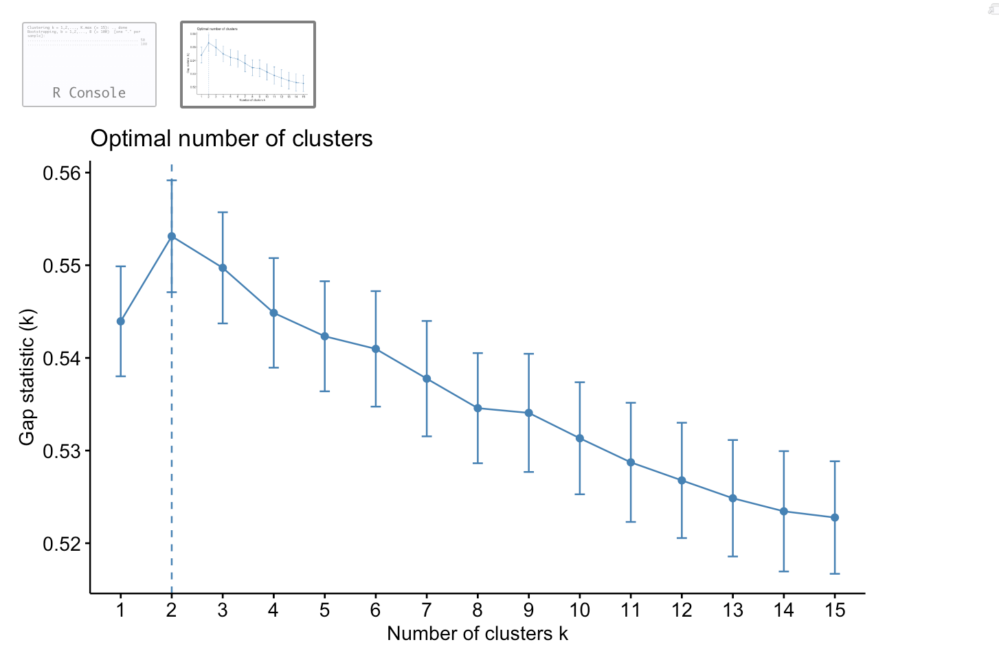

This also shows that our optimal number clusters is between 2 to 5 based on how steadily it decreases.

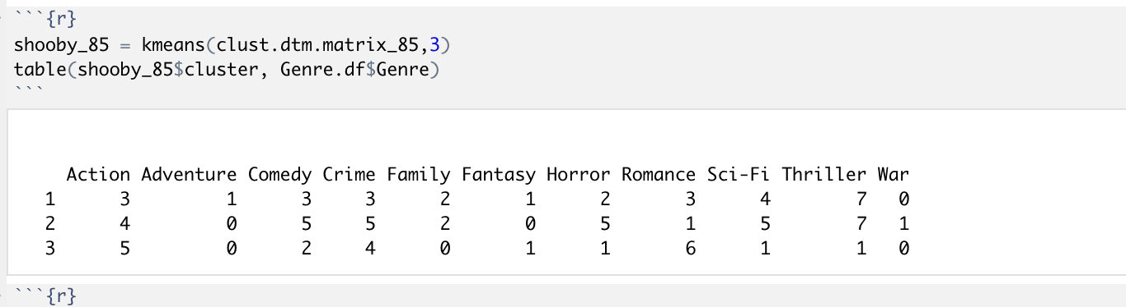

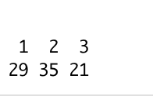

fviz_cluster(shooby_85,data = clust.dtm.matrix_85)

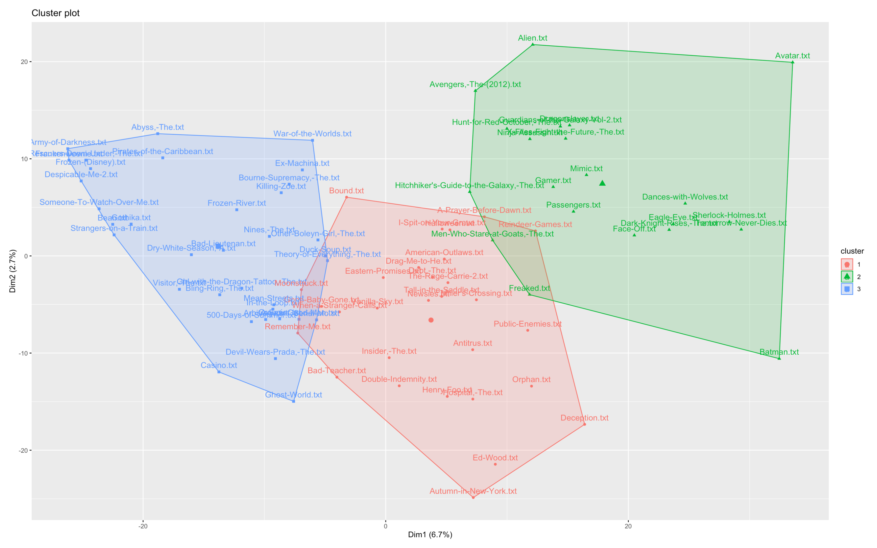

Our clustering does show some interesting results. Cluster 3 contains all the Disney type movies, if you exclude Marvel, which also overlaps with cluster 2. Unfortunately clustering didn’t yield as interesting results, especially with Genre, but it reflect in our cluster analysis.

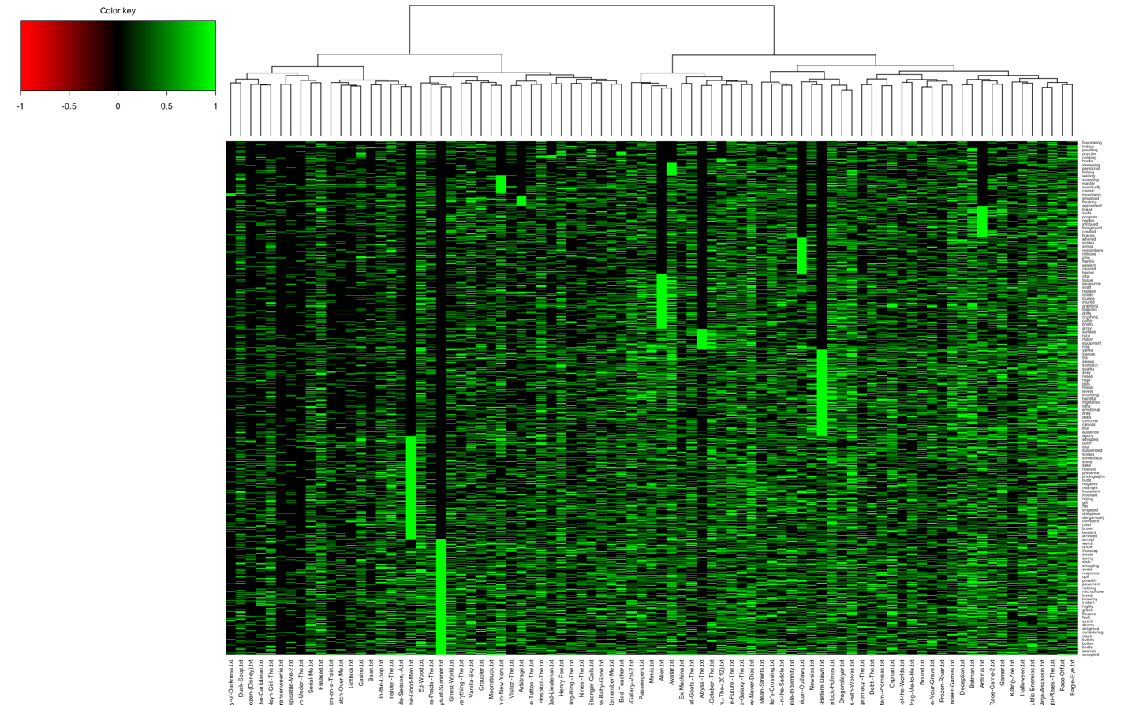

The heatmap shows the similarity of words between movies and the type of word. On the Scale a -1 shows an inverse correlation and a 1 shows a positive correlation. Because the two movies a Few Good Men, and A Prayer Before Dawn shows that they both share words, we thought it would be interesting in our analysis to further our research.

Few Good Men

Before Dawn

### Association Rules: Movies as transactions and words as products purchased

#Our clust.dtm.matrix  
movie.trans_85 = as(clust.dtm.matrix_85, "transactions")  
#With support .3 and confidence .8 -> 39 rules found  
movie.rules_85 = apriori(movie.trans_85, parameter = list(supp = .2, conf =.9))

## Apriori  
##   
## Parameter specification:  
## confidence minval smax arem aval originalSupport maxtime support minlen  
## 0.9 0.1 1 none FALSE TRUE 5 0.2 1  
## maxlen target ext  
## 10 rules FALSE  
##   
## Algorithmic control:  
## filter tree heap memopt load sort verbose  
## 0.1 TRUE TRUE FALSE TRUE 2 TRUE  
##   
## Absolute minimum support count: 17   
##   
## set item appearances ...[0 item(s)] done [0.00s].  
## set transactions ...[3182 item(s), 85 transaction(s)] done [0.01s].  
## sorting and recoding items ... [2271 item(s)] done [0.00s].  
## creating transaction tree ... done [0.00s].  
## checking subsets of size 1 2 3 4 5 6 7 done [1.04s].  
## writing ... [37948 rule(s)] done [0.10s].  
## creating S4 object ... done [0.05s].

About 38,000 rules generates

When we tried to find our rules we were able to generate about 38000 rules.

plot(movie.rules_85, "grouped")

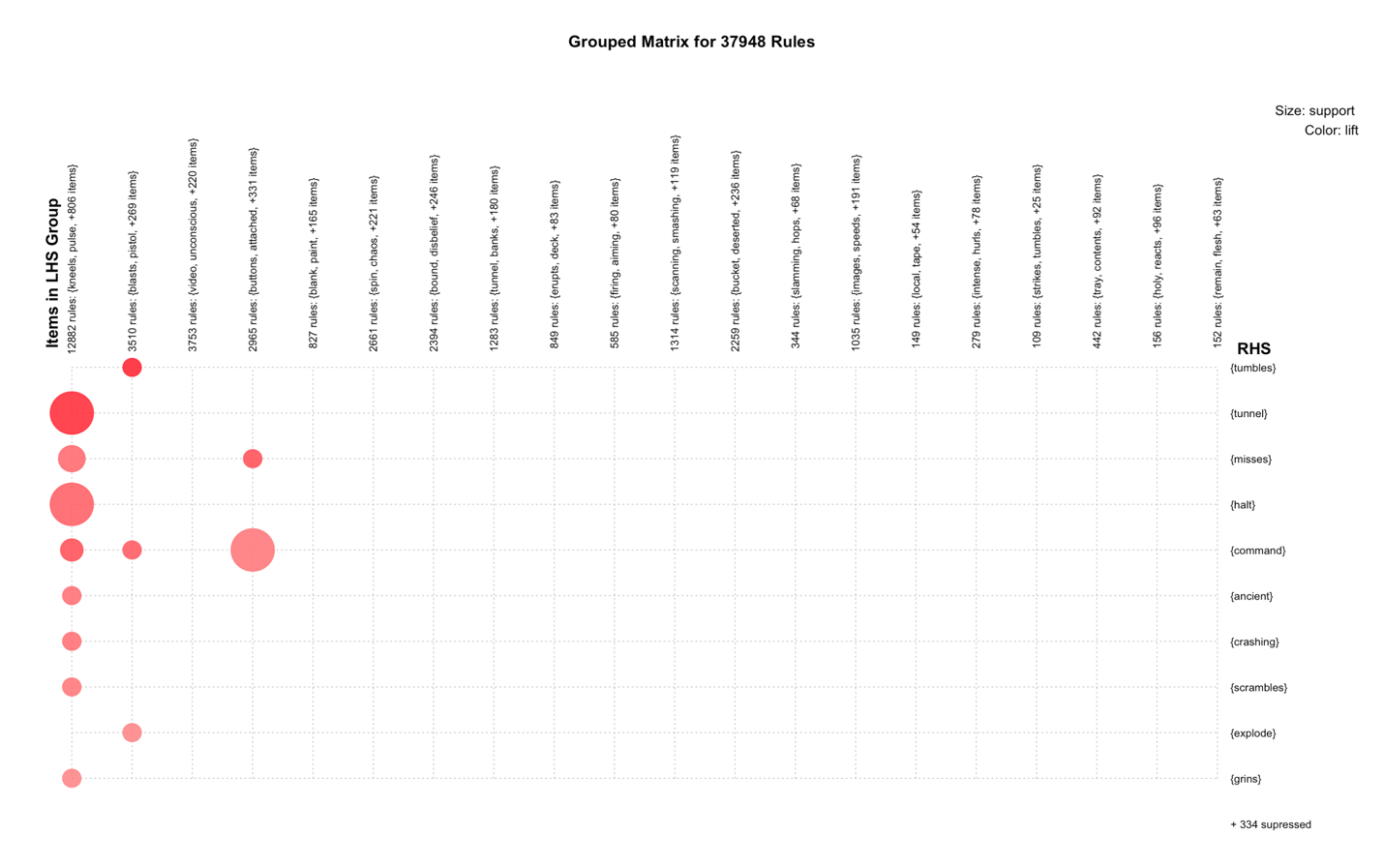

The clusters by RHS showed a lot of rules with the items in the first LHS group.

plot(movie.rules_85, "scatter", jitter = 0, interactive = F)

## Warning in plot.rules(movie.rules_85, "scatter", jitter = 0, interactive  
## = F): The parameter interactive is deprecated. Use engine='interactive'  
## instead.

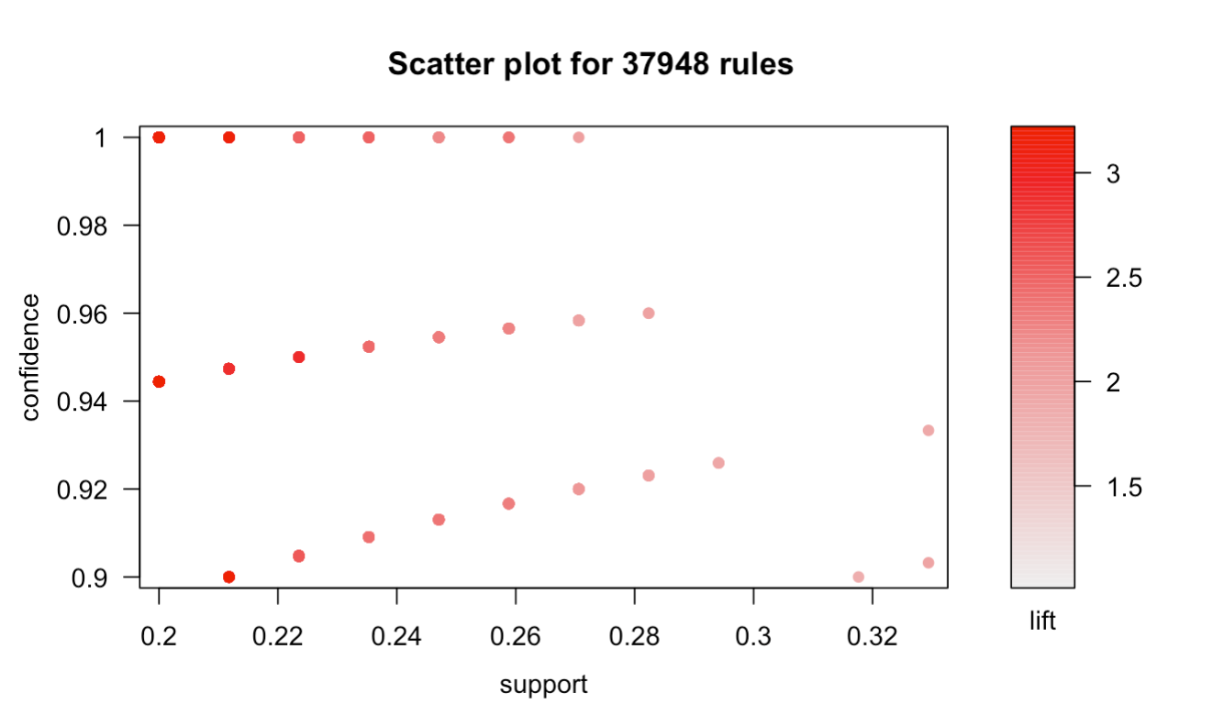

As seen above in the scatter plot, it’d be best to take rules that are the redest (highest lift value) and are in the top right corner (highest confidence and support). Let’s expore some through ruleExplorer() to determine about 10 best quality rules

Now, we are going to create subsets on rules with RHS being the most frequent word used

3 rules for 10 most frequent words:

**fuckin, ship, captain, train, elevator, dances, bridge, agent, hotel, guards**

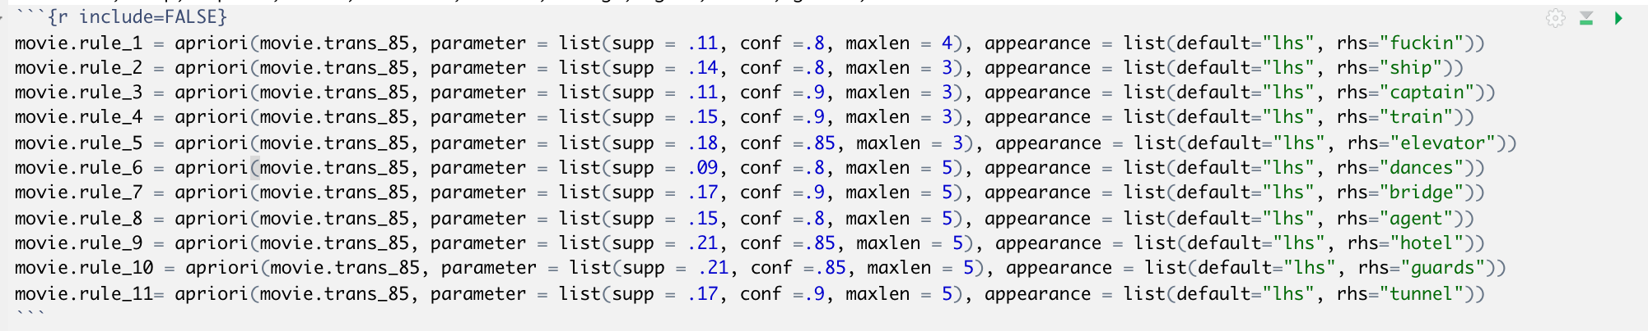

## Make plots interactive and take screenshots

movie.rule_1 = sort(movie.rule_1, by = "lift")  
inspect(movie.rule_1)

plot(movie.rule_1, "graph", interactive = F)

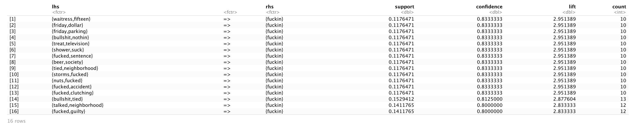

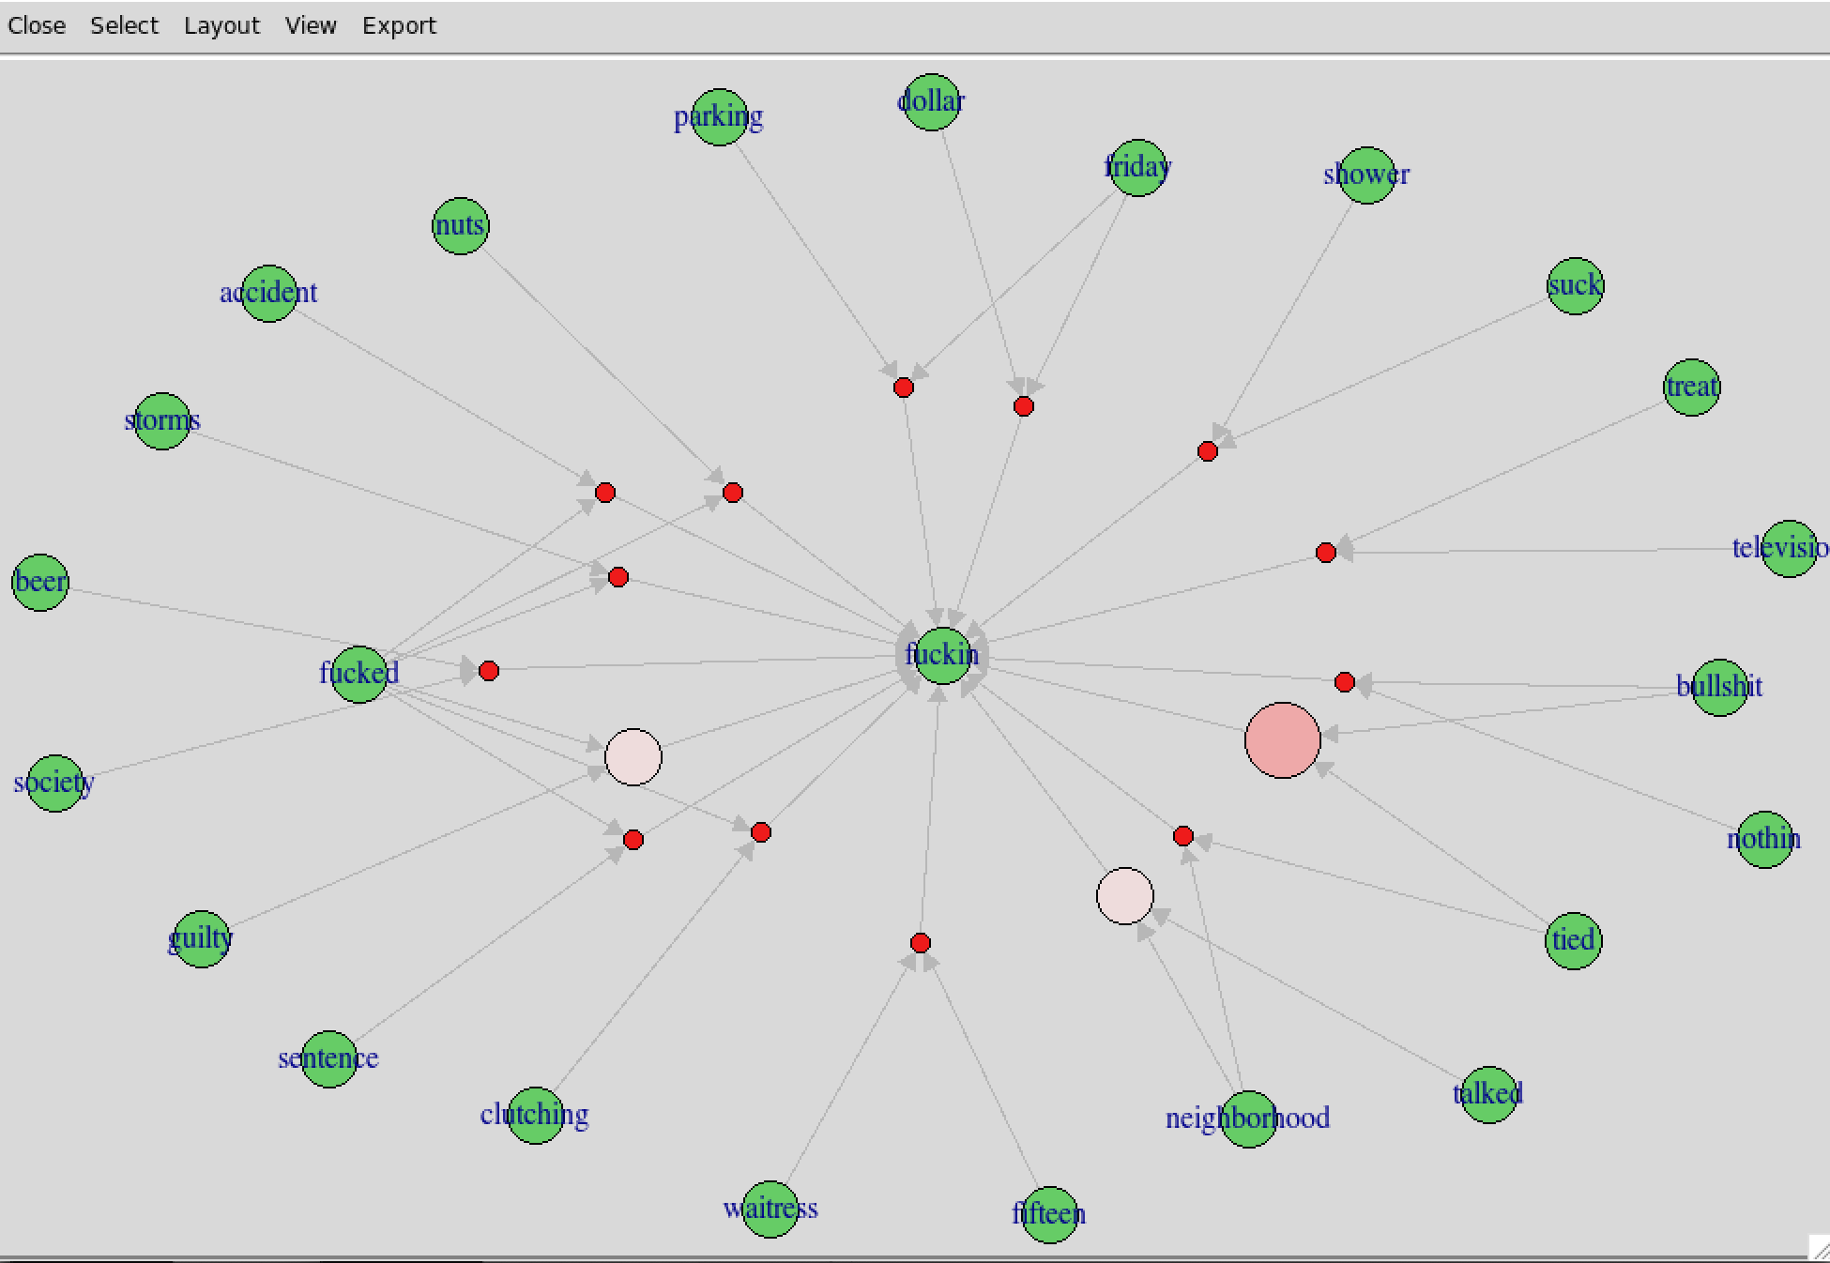

**For association rules, the darker the red the higher the lift, the bigger the circle, the higher support.**

Here we found a lot of associations with the F word. It’s also noteworthy the difference of it ending here with some ed and others in. So, society 🡪 f***ed is a negative connotation. Along with the other words like guilty. For F***in we can see that some of terms may not be negative like Friday 🡪 F***in or talked 🡪 F**in.

movie.rule_2 = sort(movie.rule_2, by = "lift")  
inspect(movie.rule_2)

plot(movie.rule_2, "graph", interactive = F)

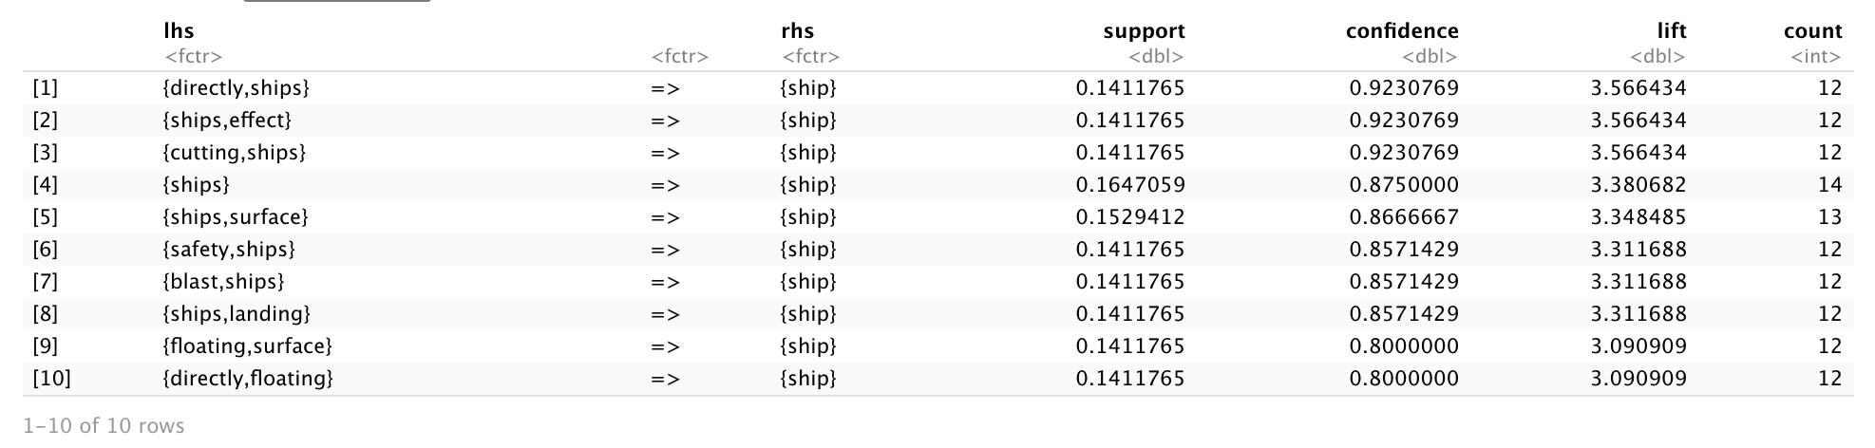

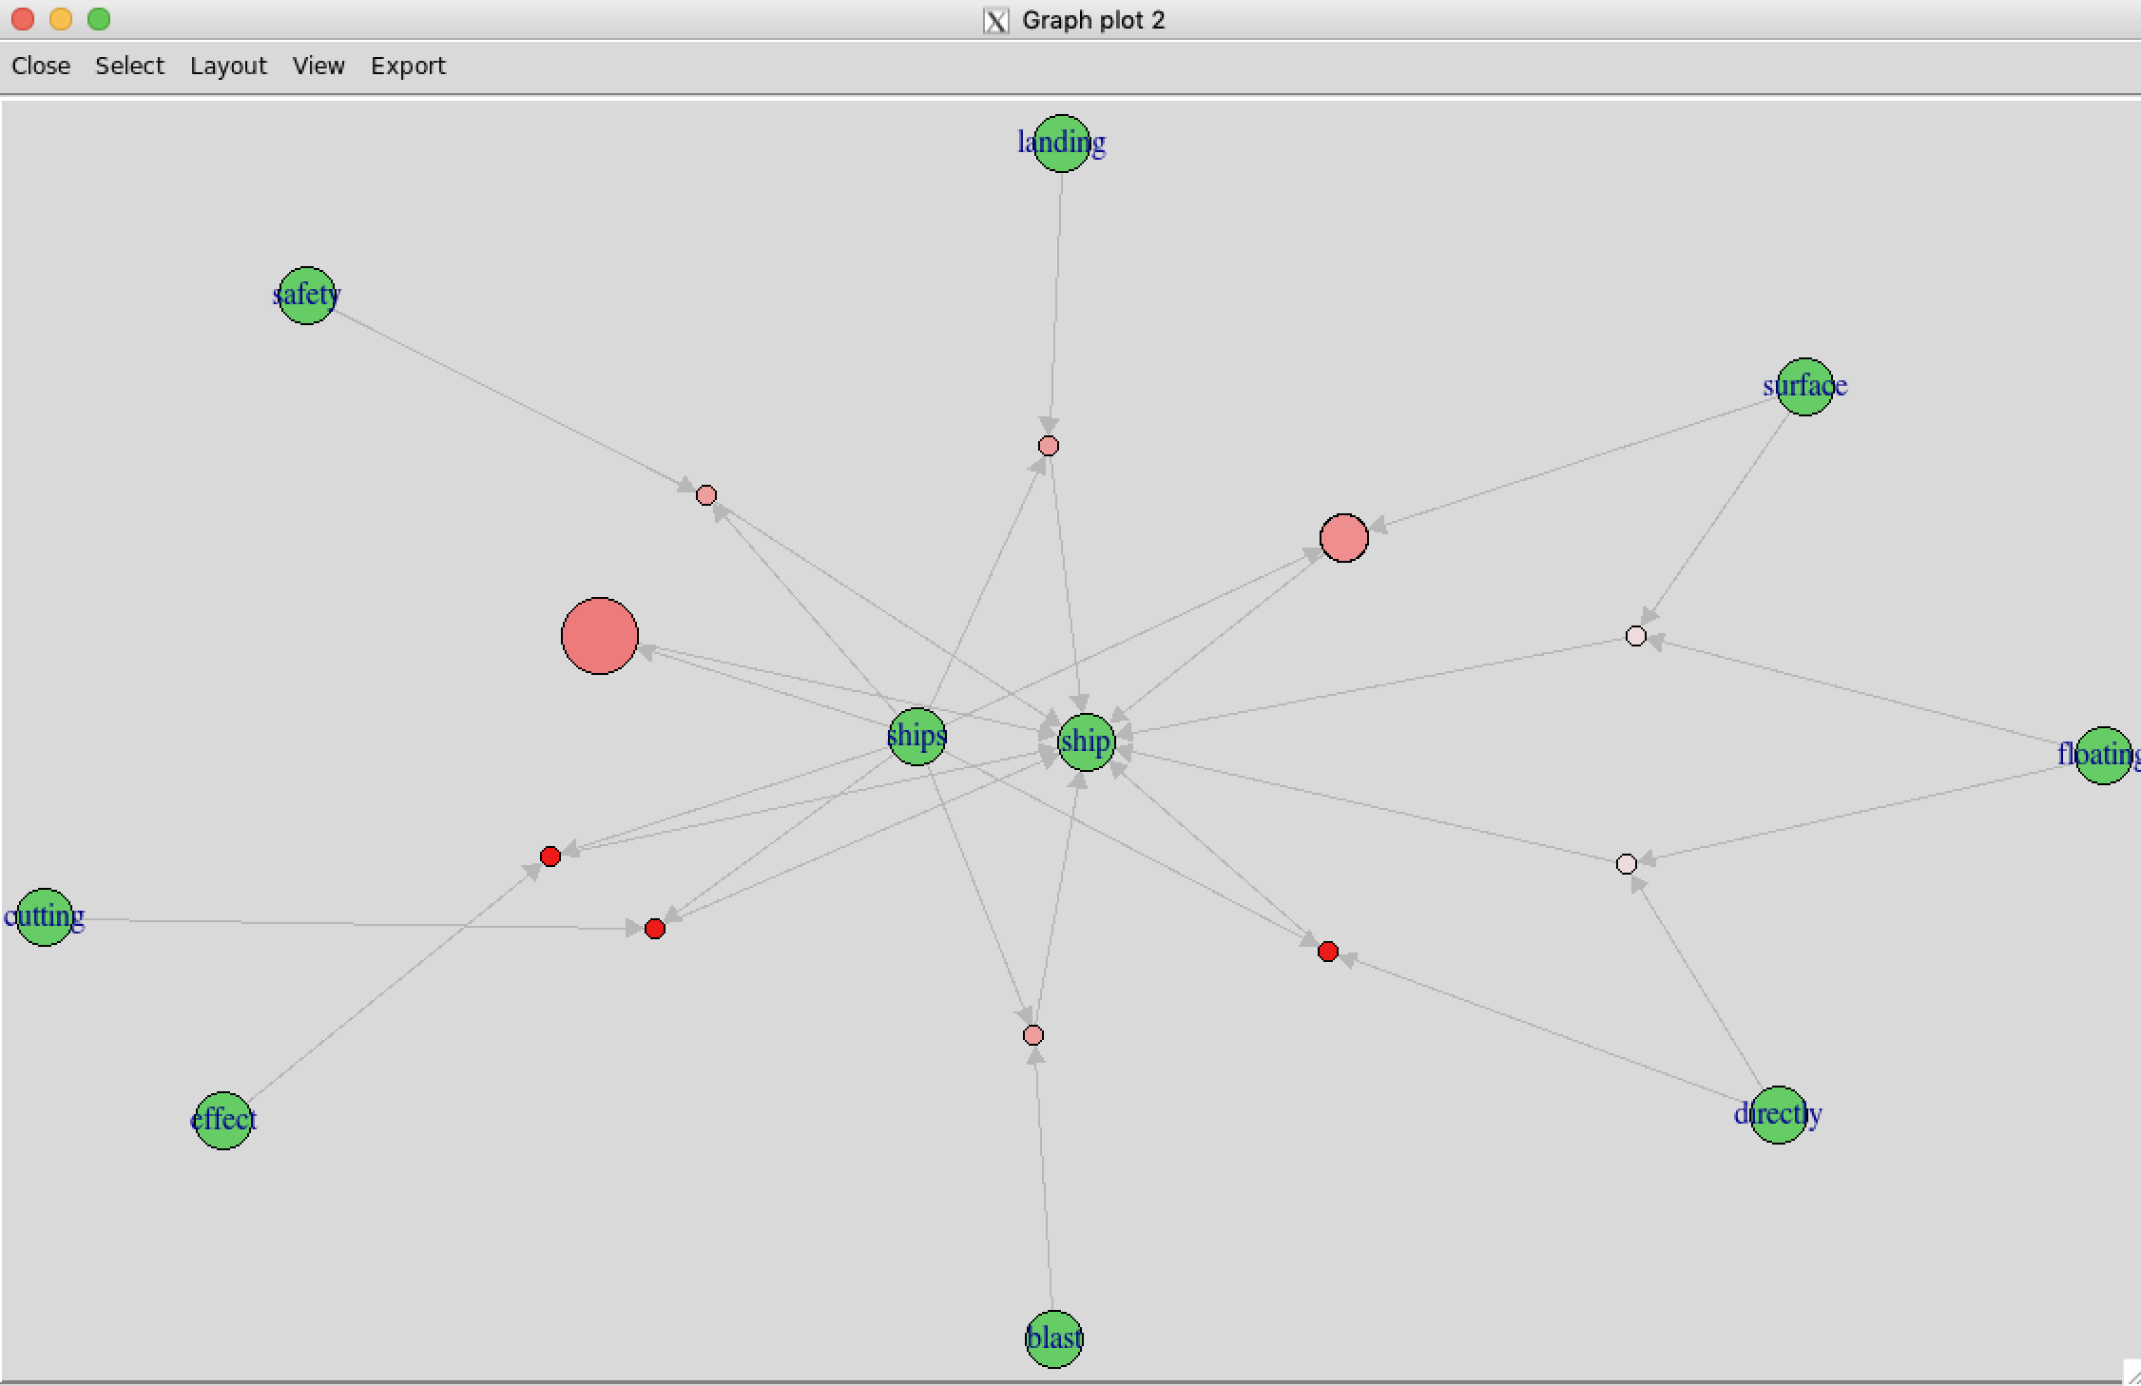

We found association rules for ships.

movie.rule_3 = sort(movie.rule_3, by = "lift")  
inspect(movie.rule_3)

plot(movie.rule_3, "graph", interactive = F)

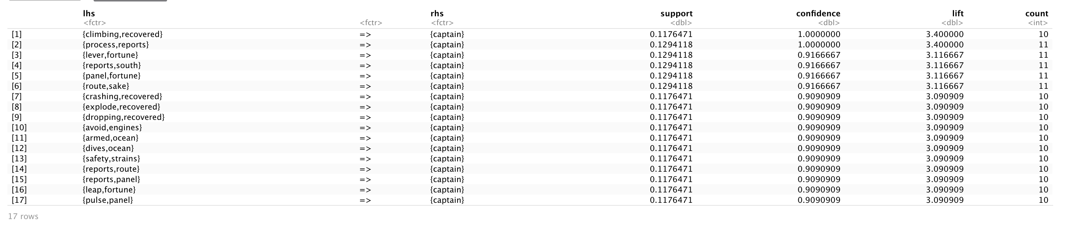

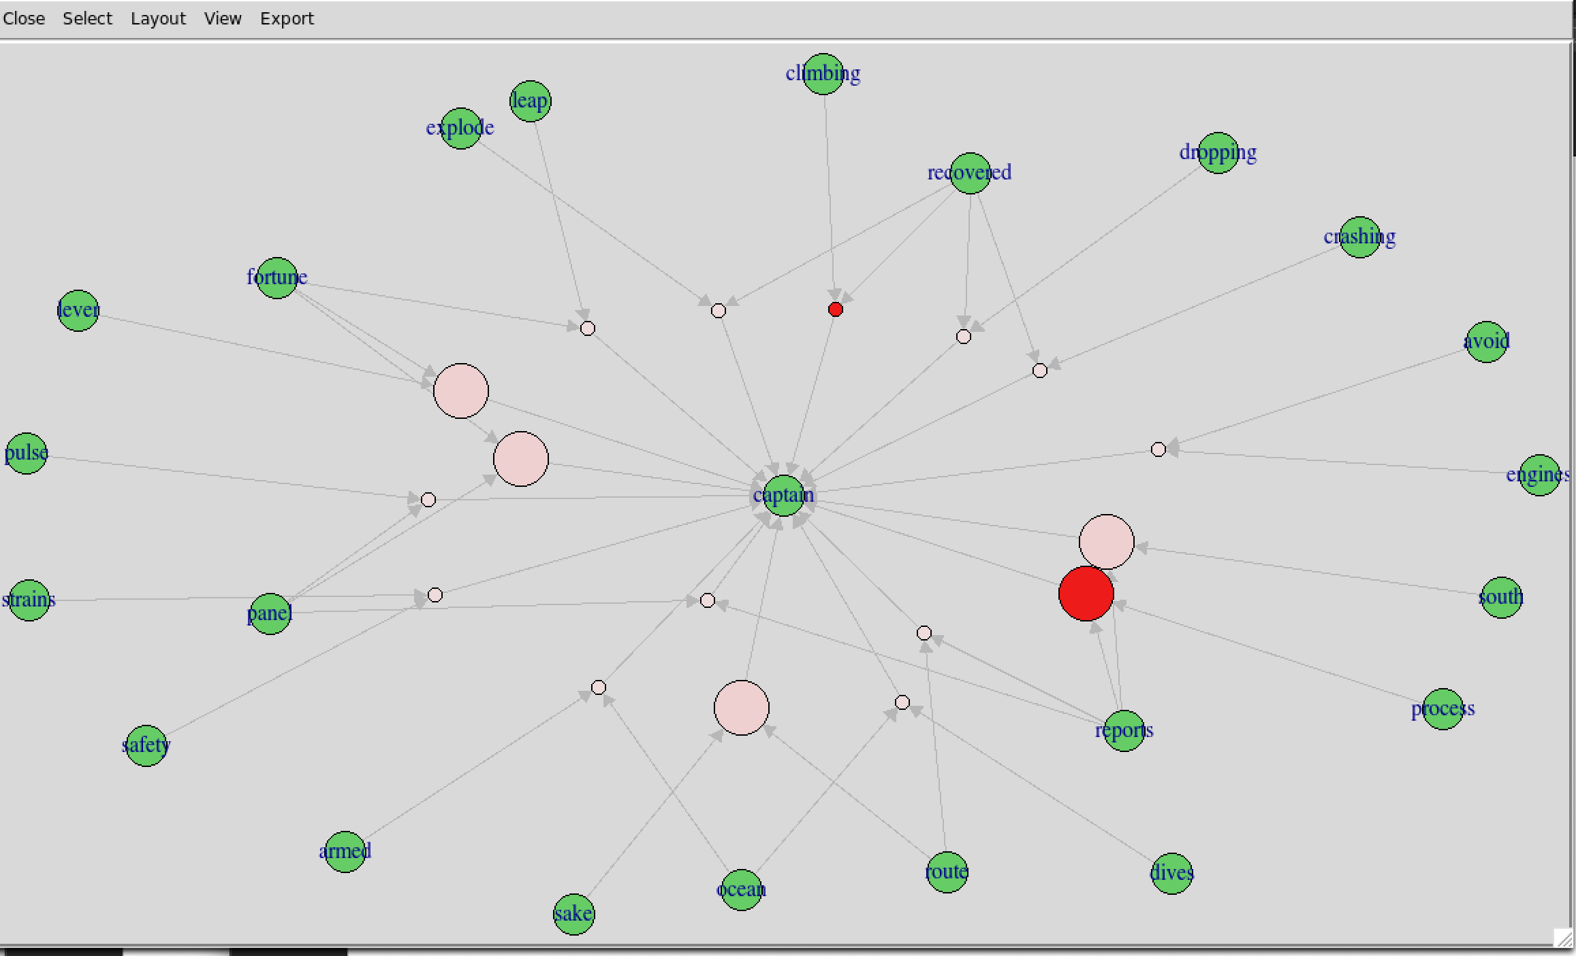

There were many associations with the word captain. Reports, Processes 🡪 Captain had both a high lift and support value.

movie.rule_4 = sort(movie.rule_4, by = "lift")  
inspect(movie.rule_4)

plot(movie.rule_4, "graph", interactive = F)

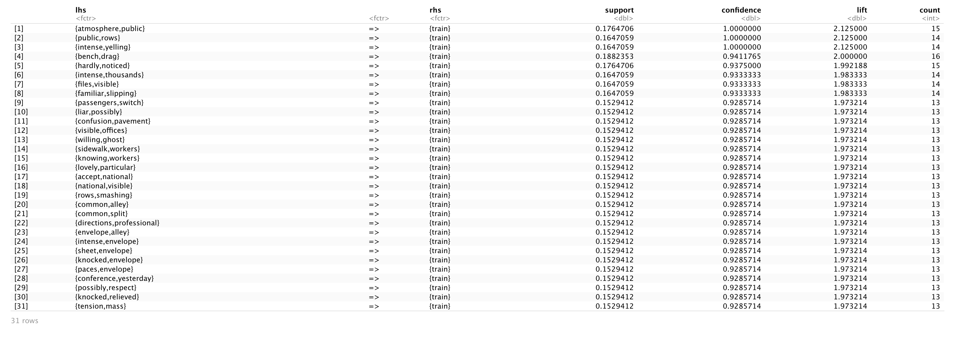

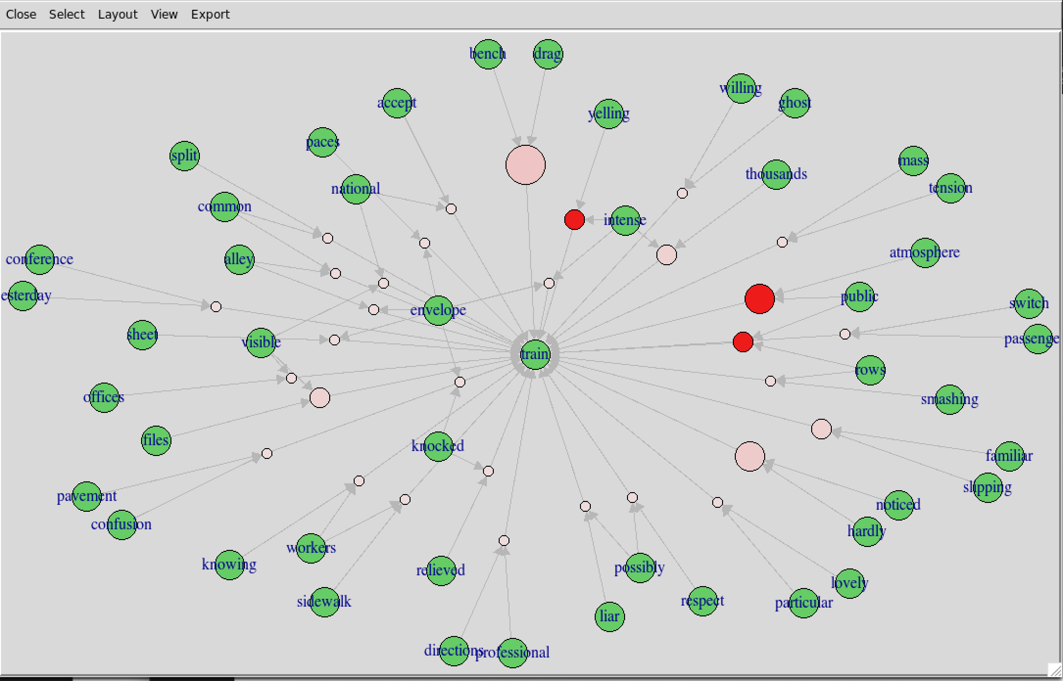

Many associations with trains. Interestingly, Yelling 🡪 Train. I could imagine this is some character yelling at a train.

movie.rule_5 = sort(movie.rule_5, by = "lift")  
inspect(movie.rule_5)

plot(movie.rule_5, "graph", interactive = F)

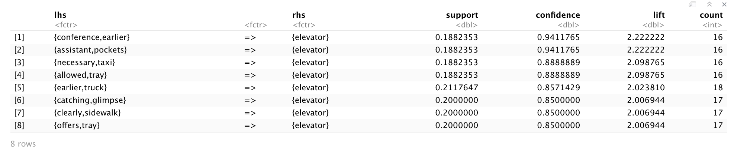

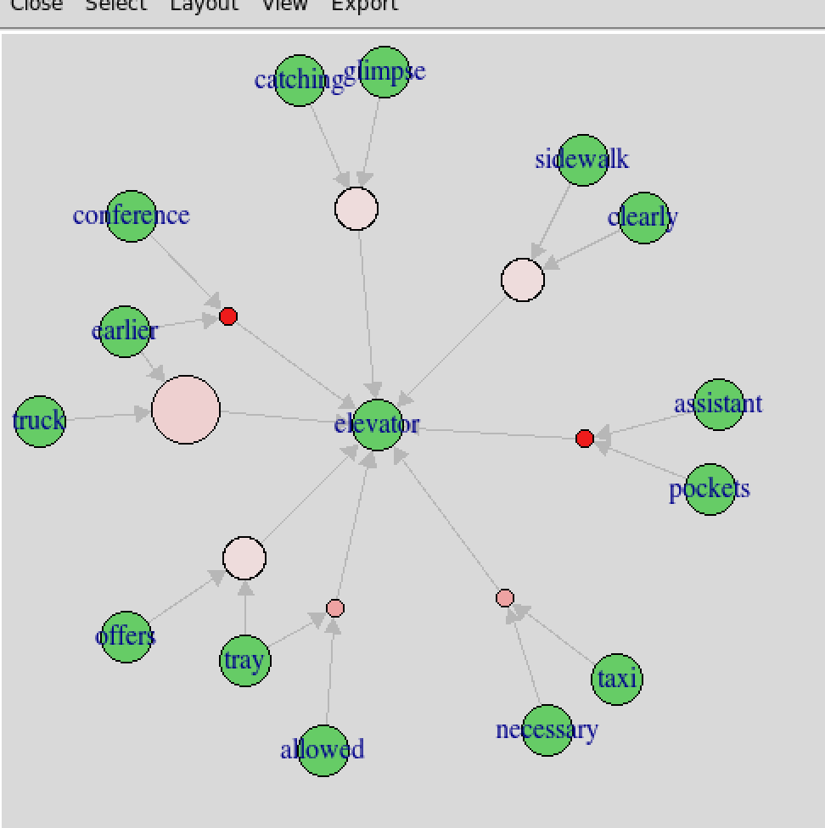

Elevator had a lot of interesting associations. Earlier, Conference, Truck 🡪 had interesting associations.

movie.rule_6 = sort(movie.rule_6, by = "lift")  
inspect(movie.rule_6)

plot(movie.rule_6, "graph", interactive = F)

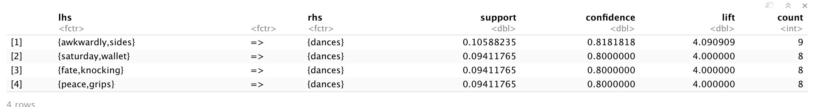

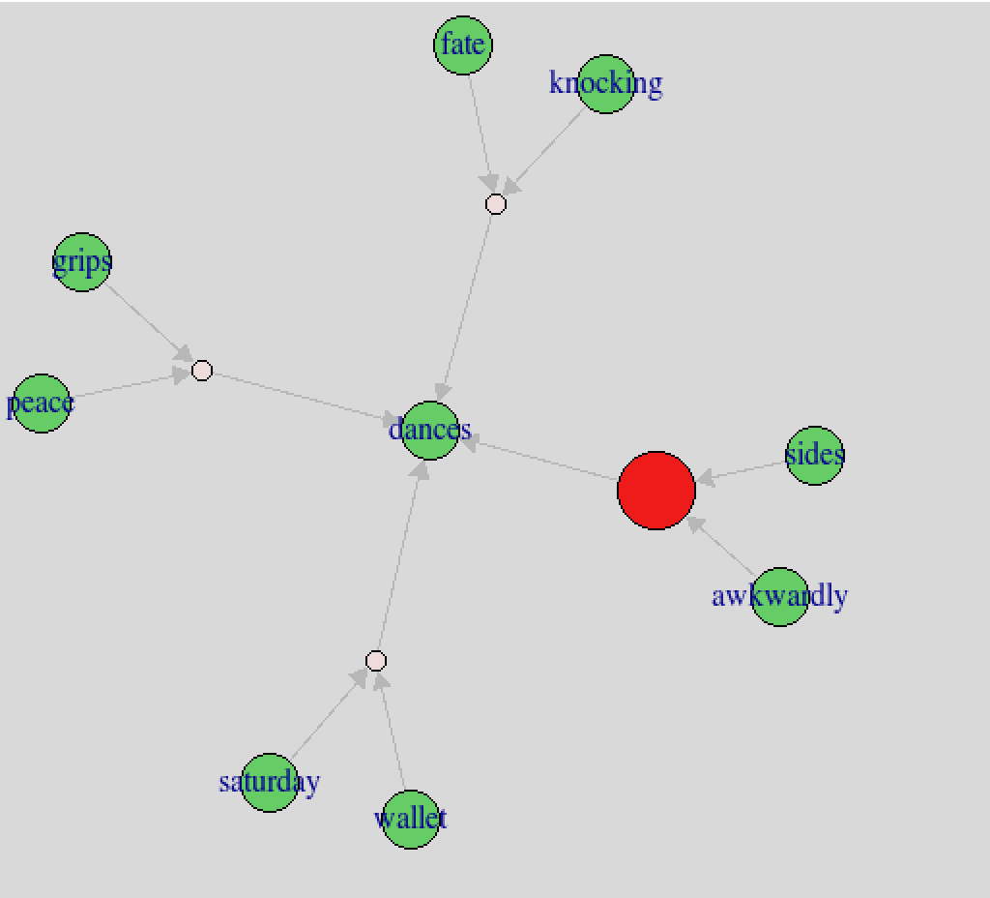

Dances, Awkwardly 🡪 Dances. I think this association is based on setting/action descriptions in the script. This could mean that actors often try to dance awkwardly when there ask for it in the move description.

movie.rule_7 = sort(movie.rule_7, by = "lift")  
inspect(movie.rule_7)

plot(movie.rule_7, "graph", interactive = F)

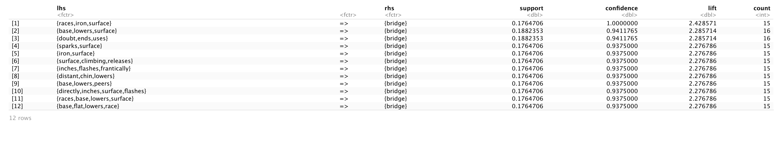

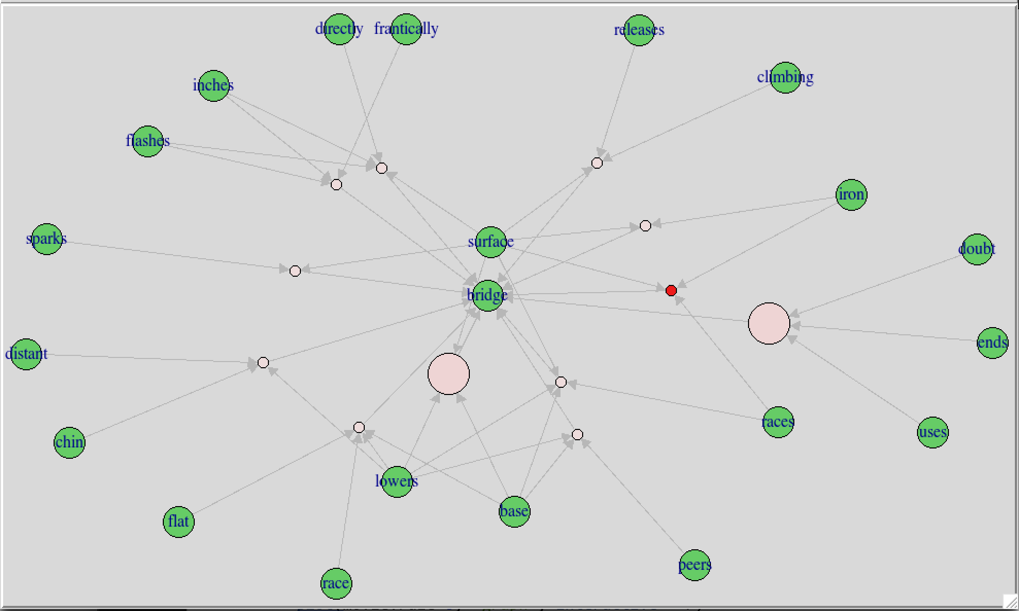

Bridge has a high support from both base and lowers.

movie.rule_8 = sort(movie.rule_8, by = "lift")  
inspect(movie.rule_8)

plot(movie.rule_8, "graph", interactive = F)

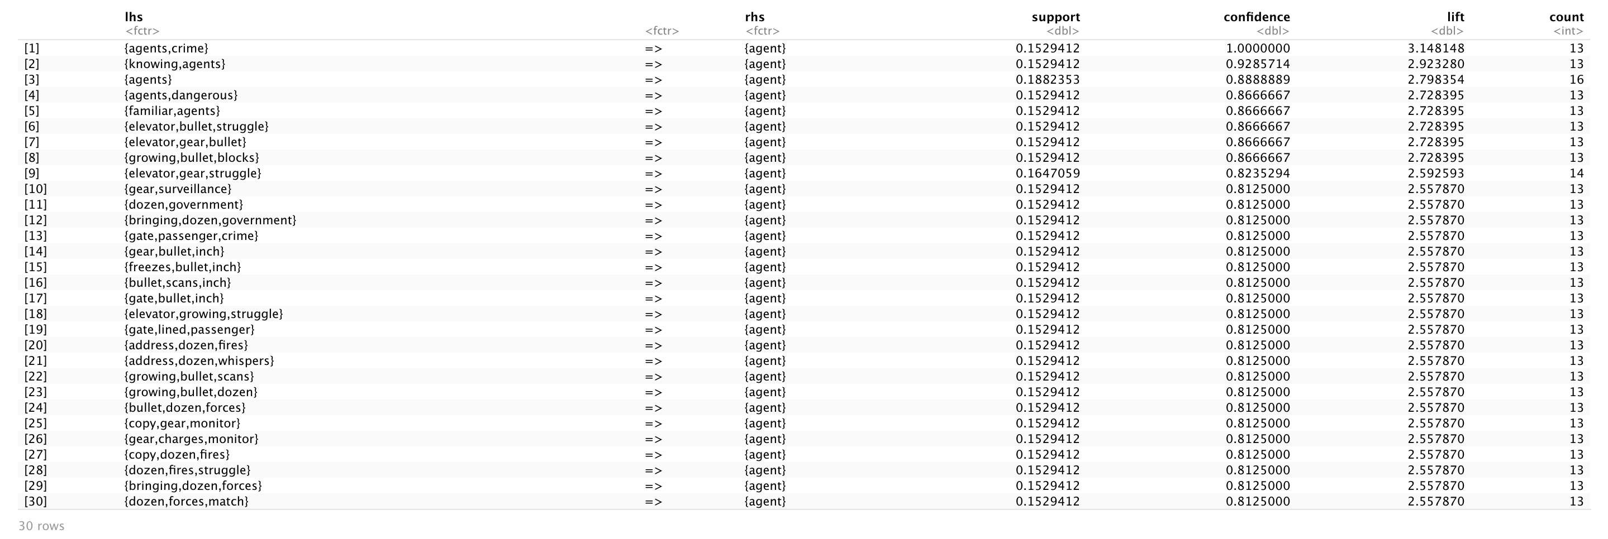

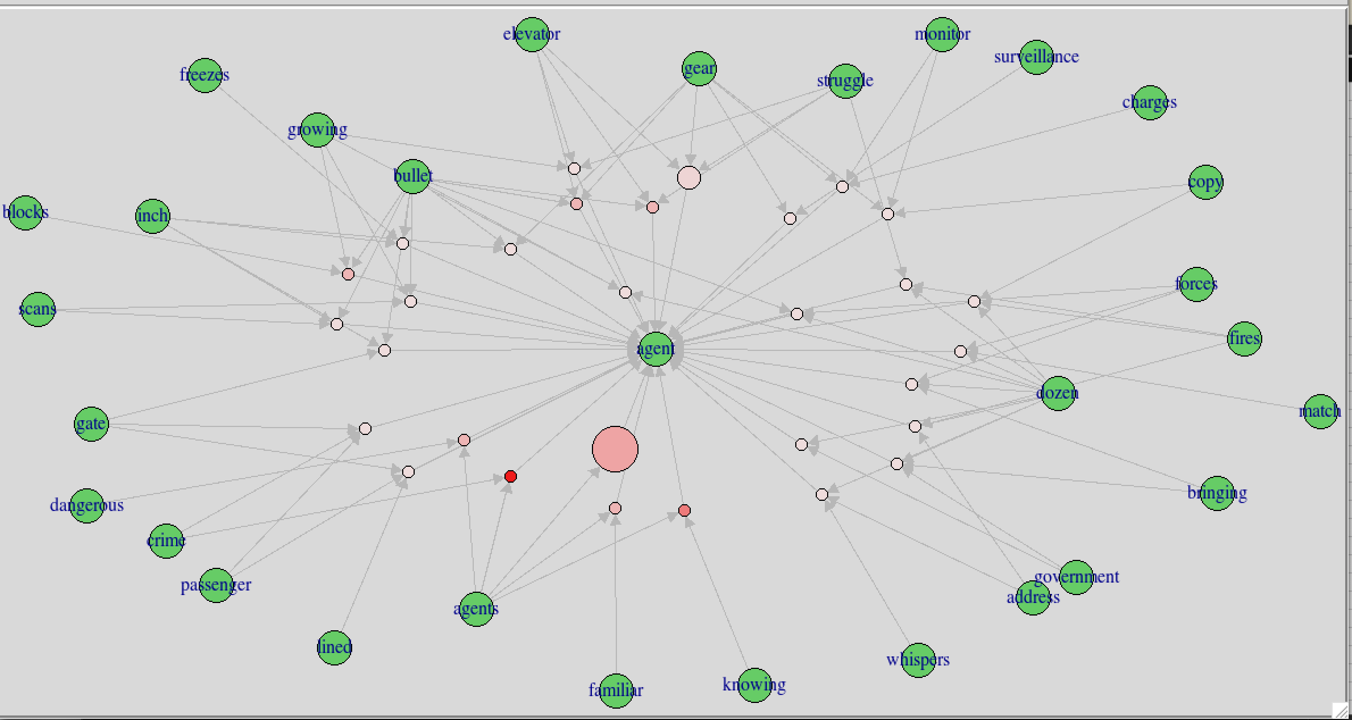

A lot of interesting associations with agent. Crime and Angents both have high lift values. Agent can be a generic term as well and mean many different things depending on the context. Agent could also be a common term for setting explanations in scripts as they can be used for any stand in character.

movie.rule_9 = sort(movie.rule_9, by = "lift")  
inspect(movie.rule_9)

plot(movie.rule_9, "graph", interactive = F)

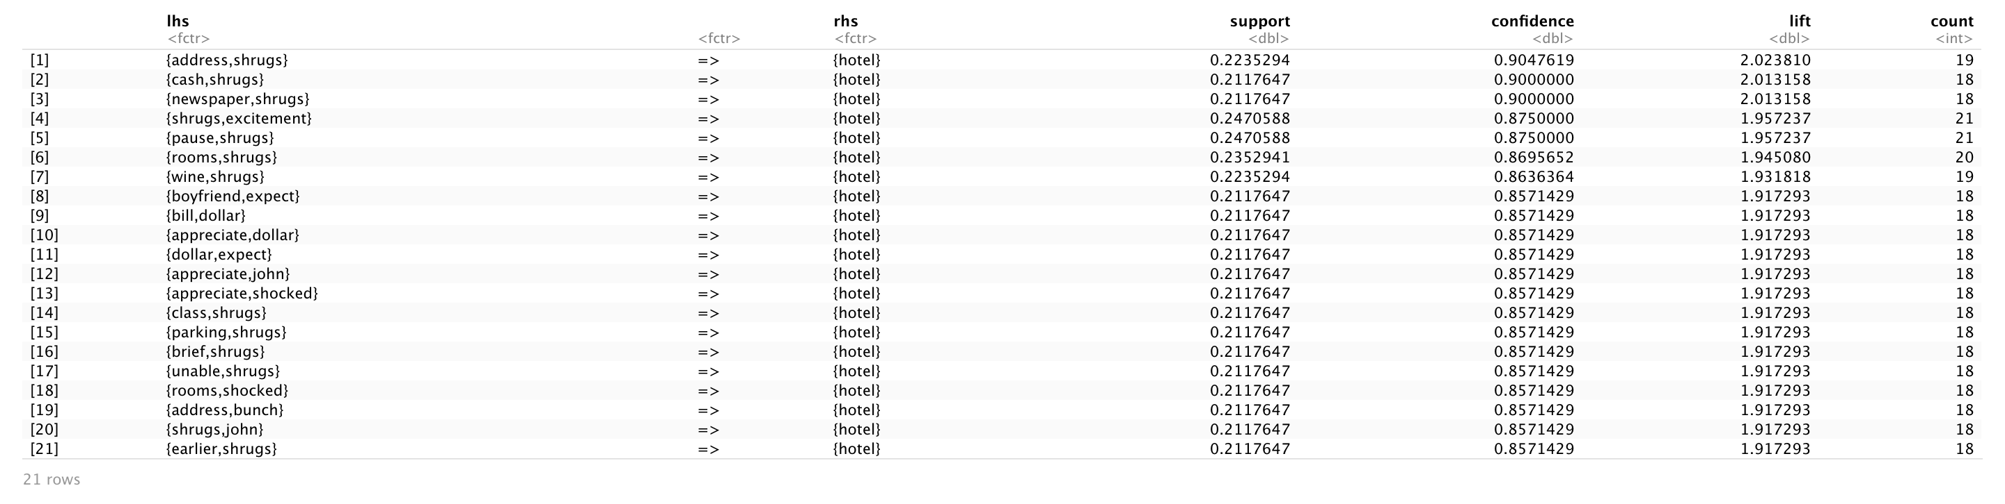

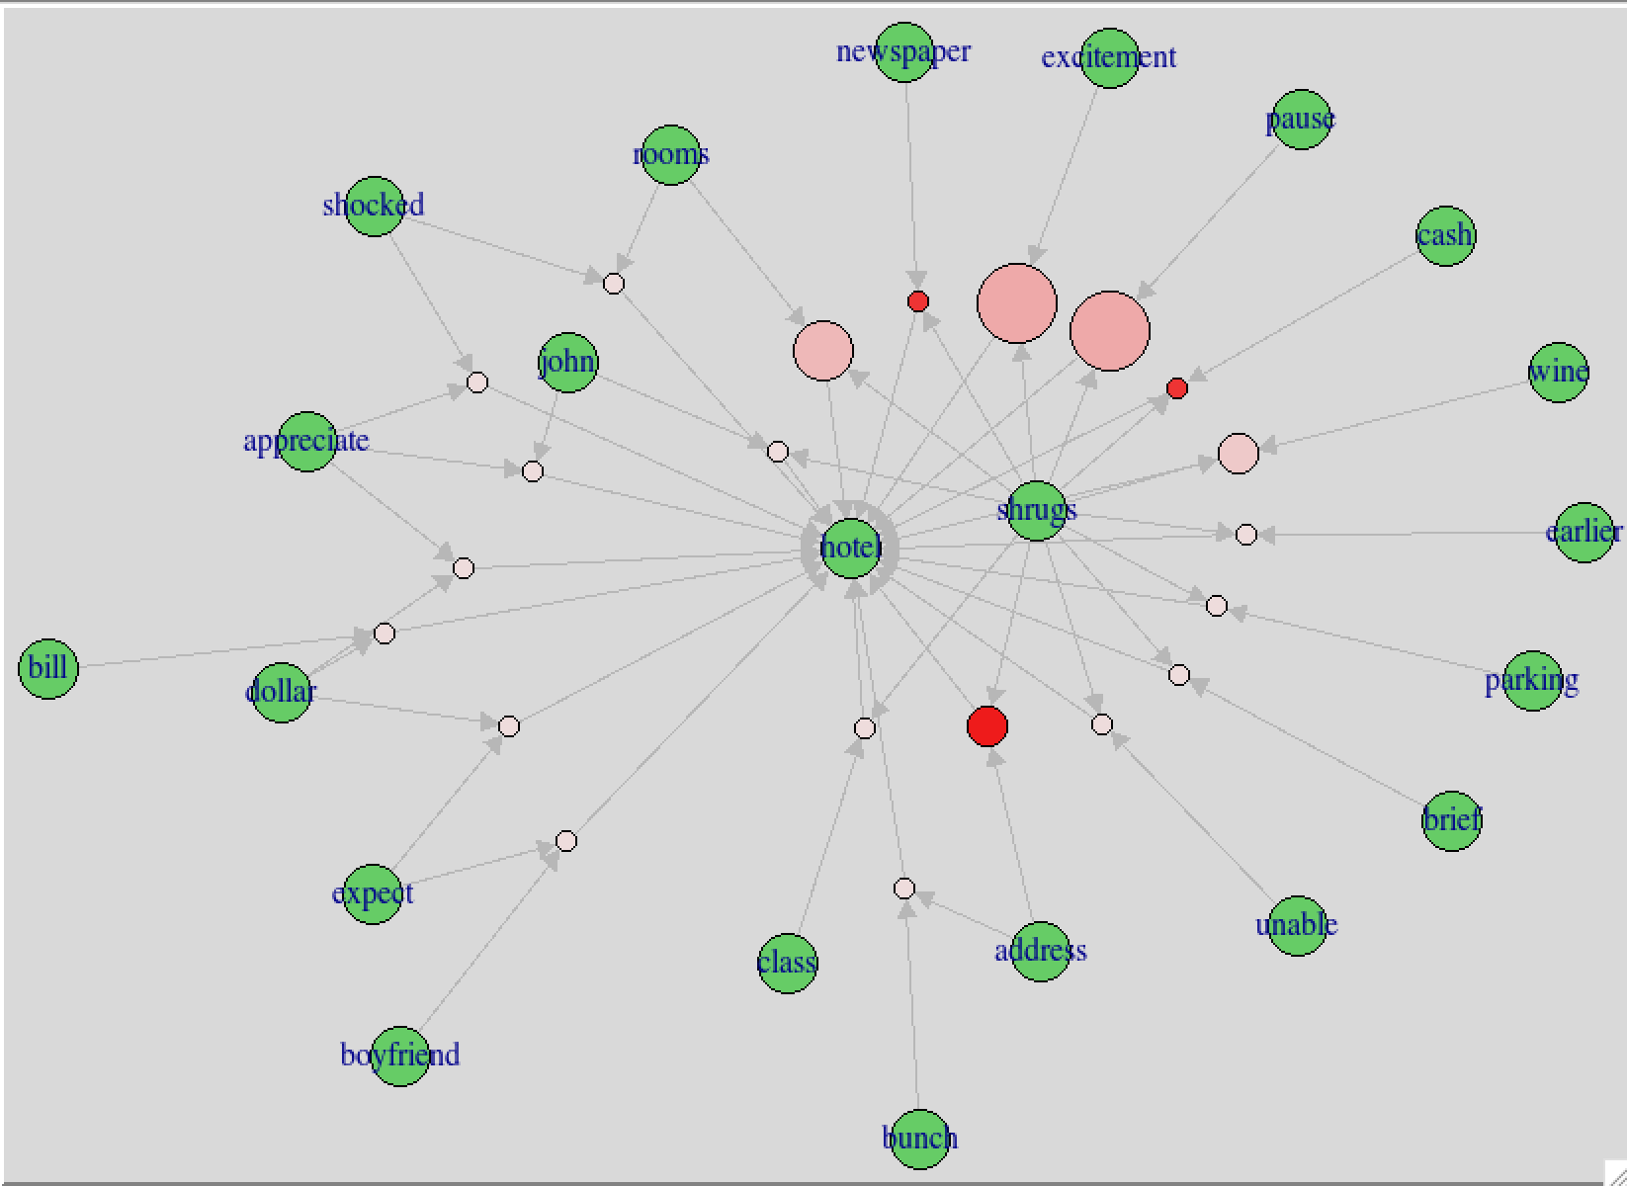

Interestingly shrugs as a high support with excitement and pause. This is again likely due to some scene descriptors specifying what the character is supposed to be doing.

movie.rule_10 = sort(movie.rule_10, by = "lift")  
inspect(movie.rule_10)

plot(movie.rule_10, "graph", interactive = F)

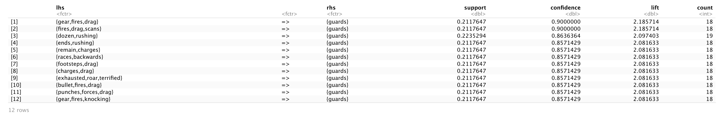

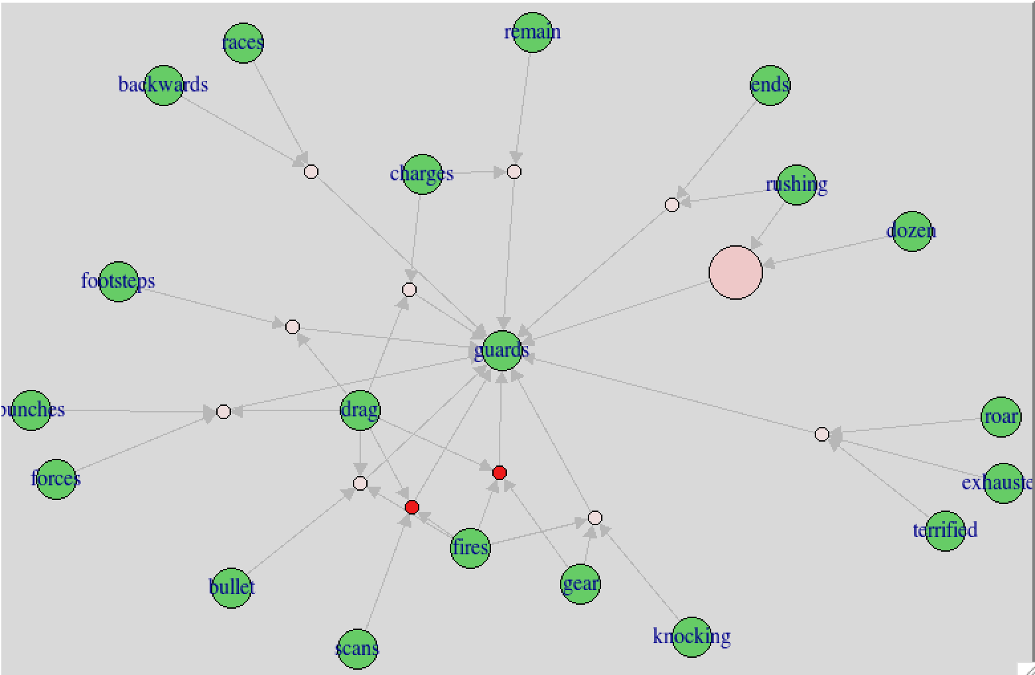

Rushing has a high support to guards.

movie.rule_11 = sort(movie.rule_11, by = "lift")  
inspect(movie.rule_11)

plot(movie.rule_11, "graph", interactive = F)

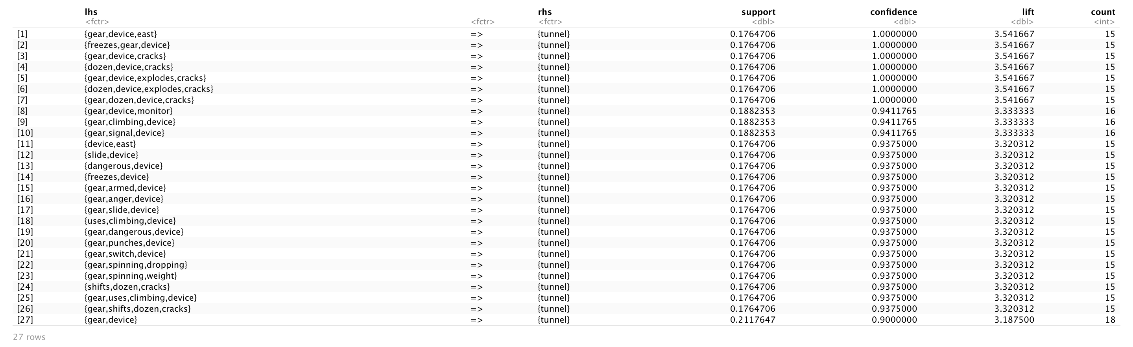

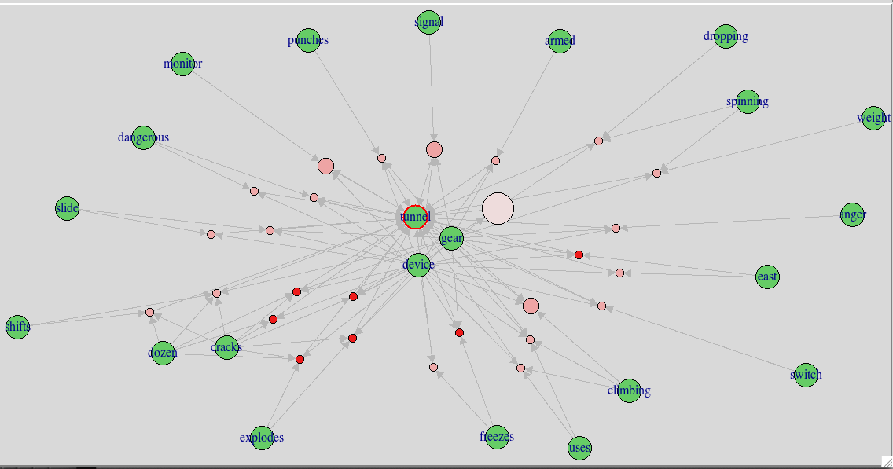

#Work on making rule subsets based on the most frequent word for example. Relate to word.frequency bar graphs

#movie.subset = apriori(movie.trans, parameter = list(supp = .1, conf =.8), appearance = list(deafault="lhs", rhs="..."))

#plot(movie.rules, "scatter", jitter = 0, interactive = T)

#Sentiment

## Word cloud for all the movies

mystopwords = c(stopwords("en"), "jack", "continued", "john")

check = Corpus(dir_85)  
check = tm_map(check, removeWords, mystopwords)

ndocs <- length(check)  
# ignore extremely rare words i.e. terms that appear in less then 1% of the documents  
minTermFreq <- ndocs * 0.15  
# ignore overly common words i.e. terms that appear in more than 50% of the documents  
maxTermFreq <- ndocs * .5  
checkDTM = DocumentTermMatrix(check,  
 control = list(  
 wordLengths=c(4, 15),  
 removePunctuation = T,  
 removeNumbers = T,  
 #stemming = T,  
 #removeWords("bateman"),  
 bounds = list(global = c(minTermFreq, maxTermFreq))  
 ))  
checkTDM = t(checkDTM)  
check.mat = as.matrix(checkTDM)

word.freq_check = sort(rowSums(check.mat), decreasing = T)

dim(check.mat)

## [1] 3200 85

Below is the word cloud of the most frequently occurring words in movie scripts – it’s for all 85 movies.

Two-Movies: A Few Good Men & A Prayer Before Dawn

path_one = "~/OneDrive - MNSCU/myGithub/Unsupervised_Learning/Movie-Script-Unsupervised-Learning-Methods-Analyses/One_movie"  
dir_1 = DirSource(paste(path_one, sep=""), encoding = "UTF-8")  
corpus_1 = Corpus(dir_1)  
head(summary(corpus_1))

## Length Class Mode  
## A-Few-Good-Men.txt 2 PlainTextDocument list

path_second = "~/OneDrive - MNSCU/myGithub/Unsupervised_Learning/Movie-Script-Unsupervised-Learning-Methods-Analyses/Second_movie"  
dir_2 = DirSource(paste(path_second, sep=""), encoding = "UTF-8")  
corpus_2 = Corpus(dir_2)  
head(summary(corpus_2))

## Length Class Mode  
## A-Prayer-Before-Dawn.txt 2 PlainTextDocument list

ndocs <- length(corpus_1)  
# ignore extremely rare words i.e. terms that appear in less then 1% of the documents  
minTermFreq <- ndocs * 0.05  
# ignore overly common words i.e. terms that appear in more than 50% of the documents  
maxTermFreq <- ndocs * .5  
dtm_1 = DocumentTermMatrix(corpus_1,  
 control = list(  
 stopwords = ("en"),   
 wordLengths=c(5, 15),  
 removePunctuation = T,  
 removeNumbers = T  
 #stemming = T,  
 #removeWords("bateman"),  
 #bounds = list(global = c(minTermFreq, maxTermFreq))  
 ))

ndocs <- length(corpus_2)  
# ignore extremely rare words i.e. terms that appear in less then 1% of the documents  
minTermFreq <- ndocs * 0.05  
# ignore overly common words i.e. terms that appear in more than 50% of the documents  
maxTermFreq <- ndocs * .5  
dtm_2 = DocumentTermMatrix(corpus_2,  
 control = list(  
 stopwords = ("end"),   
 wordLengths=c(5, 15),  
 removePunctuation = T,  
 removeNumbers = T  
 #stemming = T,  
 #removeWords("bateman"),  
 #bounds = list(global = c(minTermFreq, maxTermFreq))  
 ))

### Two movies

tdm_1 = t(dtm_1)  
tdm_2 = t(dtm_2)  
#Removing sparse terms  
tdm_no_sparse_1 = removeSparseTerms(tdm_1, sparse = .99)  
tdm.mat_1 <- as.matrix(tdm_no_sparse_1)  
tdm_no_sparse_2 = removeSparseTerms(tdm_2, sparse = .99)  
tdm.mat_2 <- as.matrix(tdm_no_sparse_2)

**Move#1 A Few Good Men**

#First 20 most frequent words for Move#1  
word.freq_1 = sort(rowSums(tdm.mat_1), decreasing = T)  
barplot(word.freq_1[1:20], cex.names = .8)

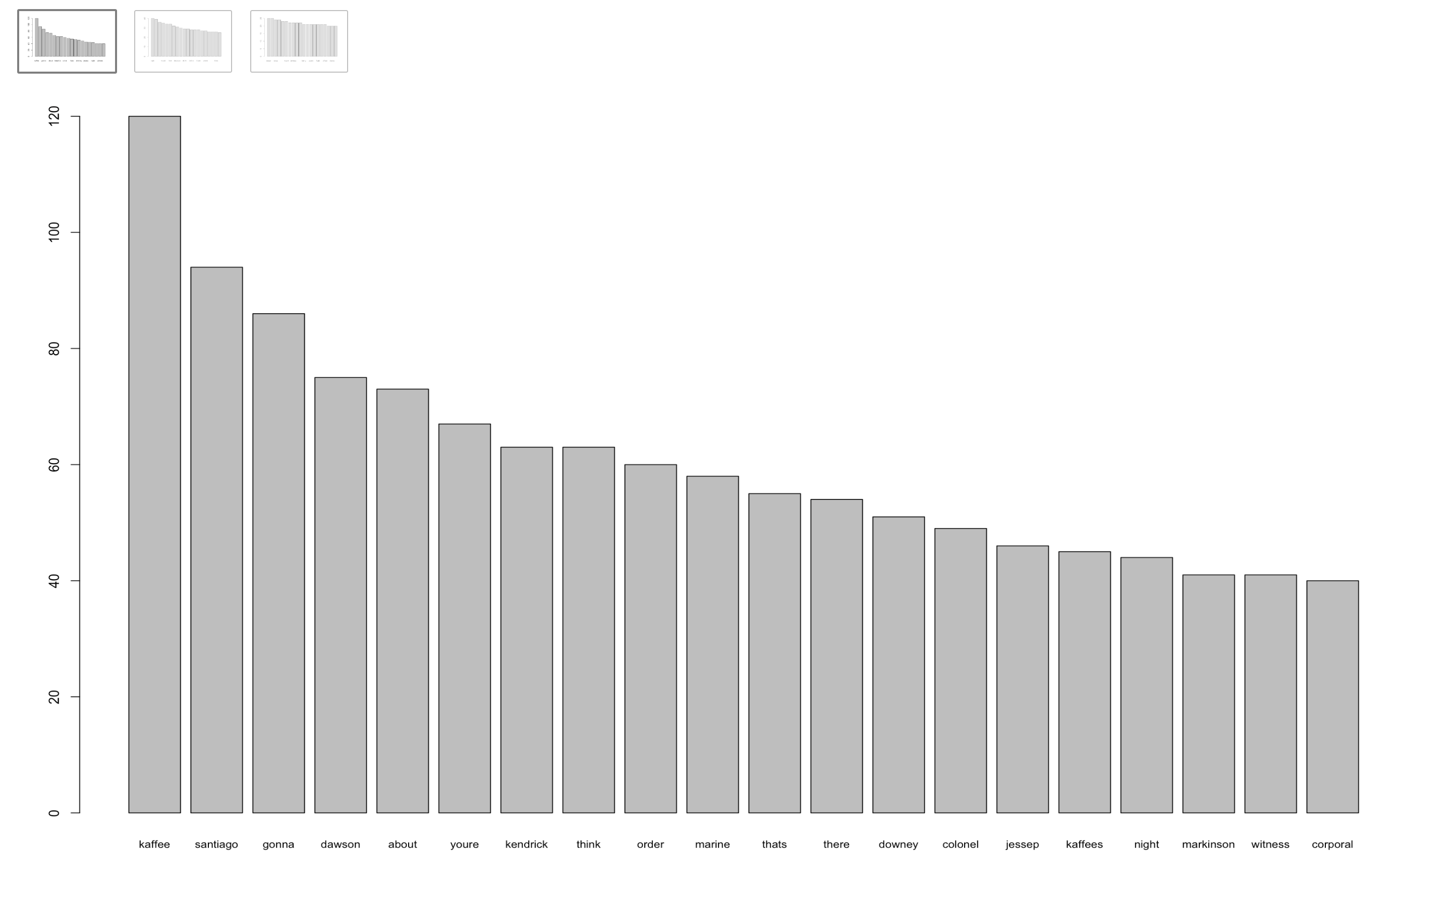

#Next 20 most frequent words  
barplot(word.freq_1[21:40], cex.names = .8)

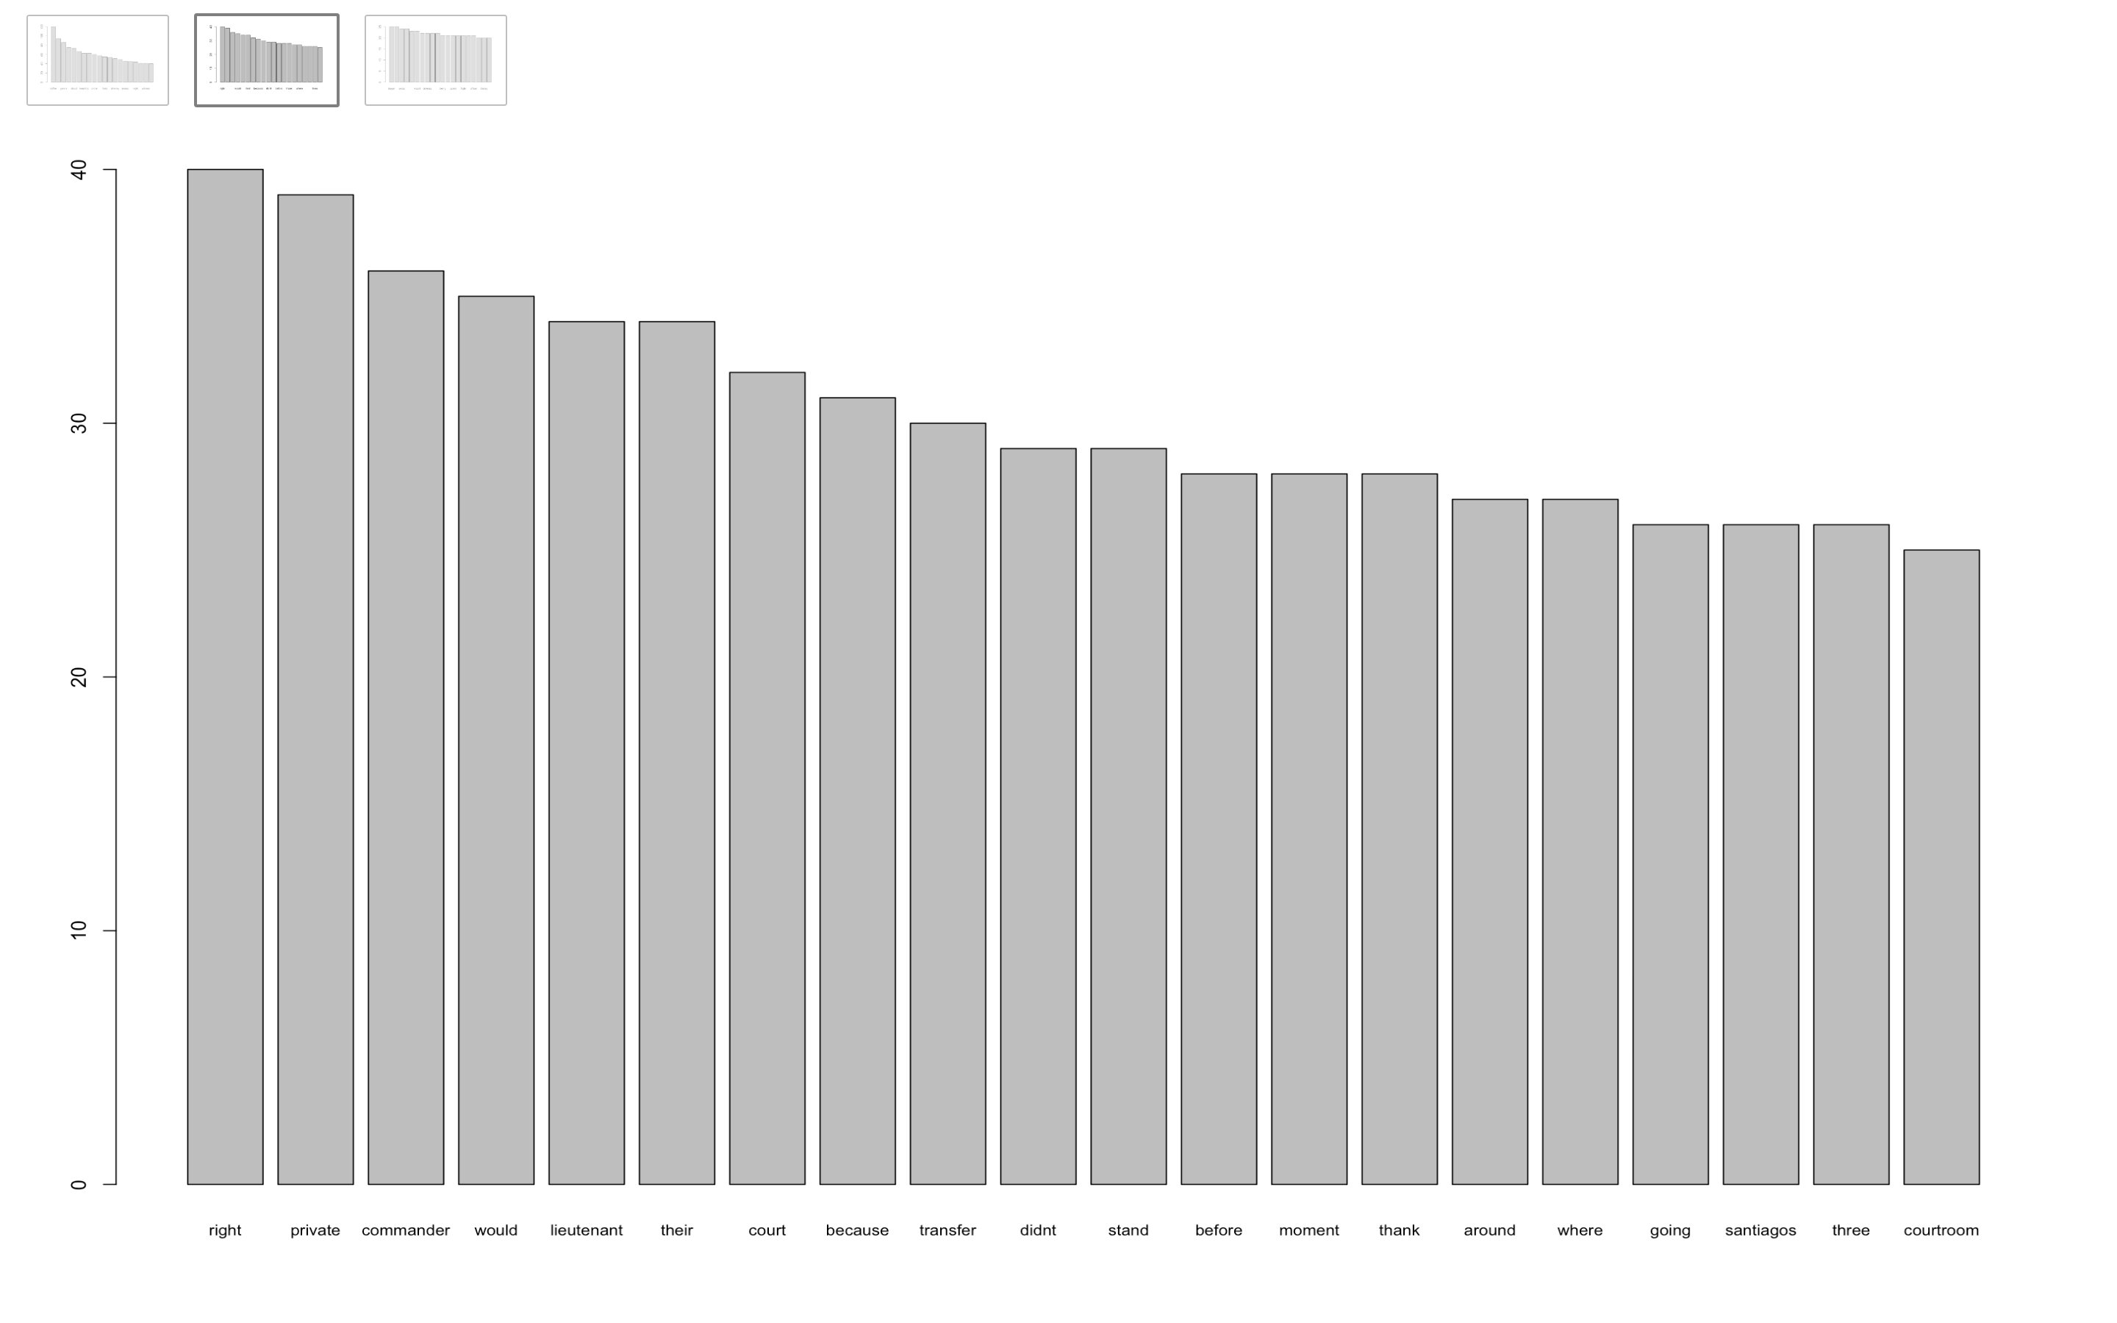

#Next 20 most frequent words  
barplot(word.freq_1[41:60], cex.names = .8)

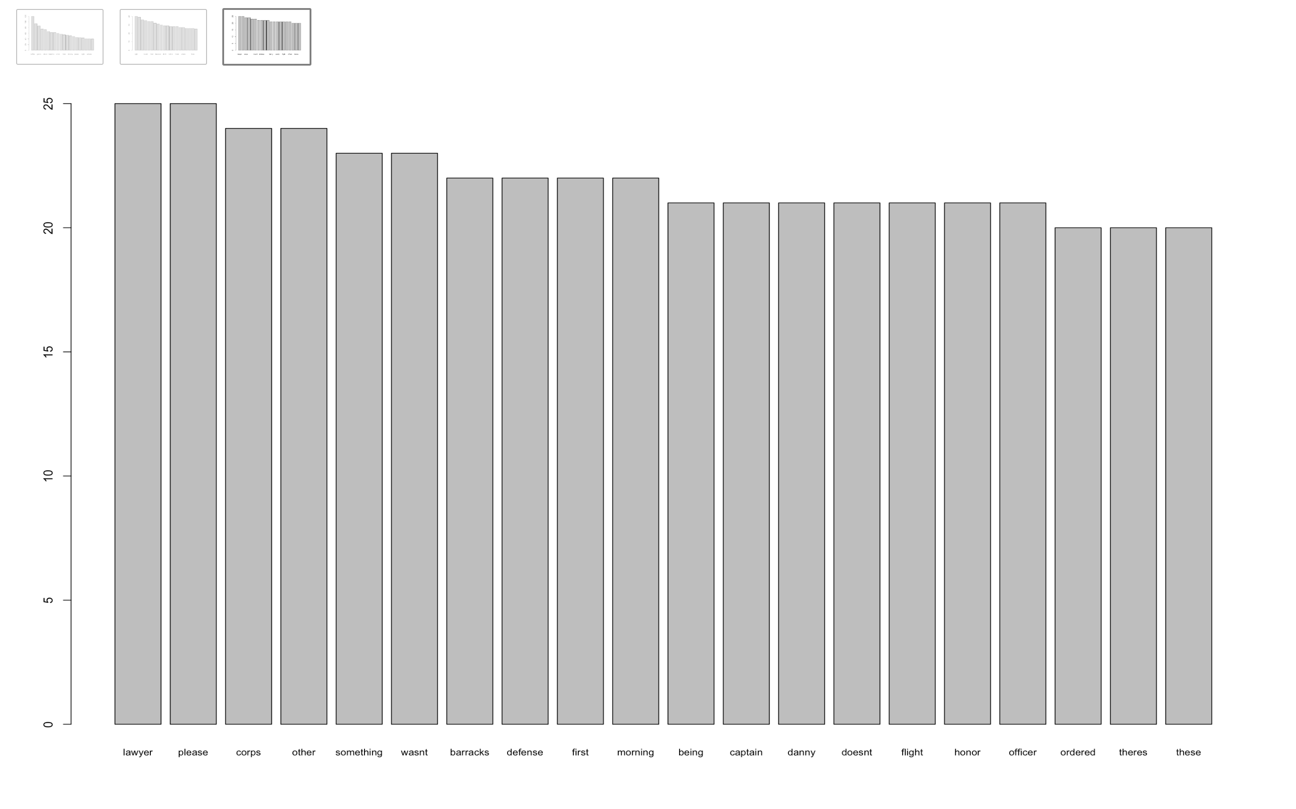

dim(tdm.mat_1)

## [1] 2376 1

#Word Cloud for Movie#1  
#wordcloud(words = names(word.freq_1[4:2376]), freq = word.freq_check, min.freq = 100, col = rainbow(1000), max.words = 50)

**Move#1 A Few Good Men**

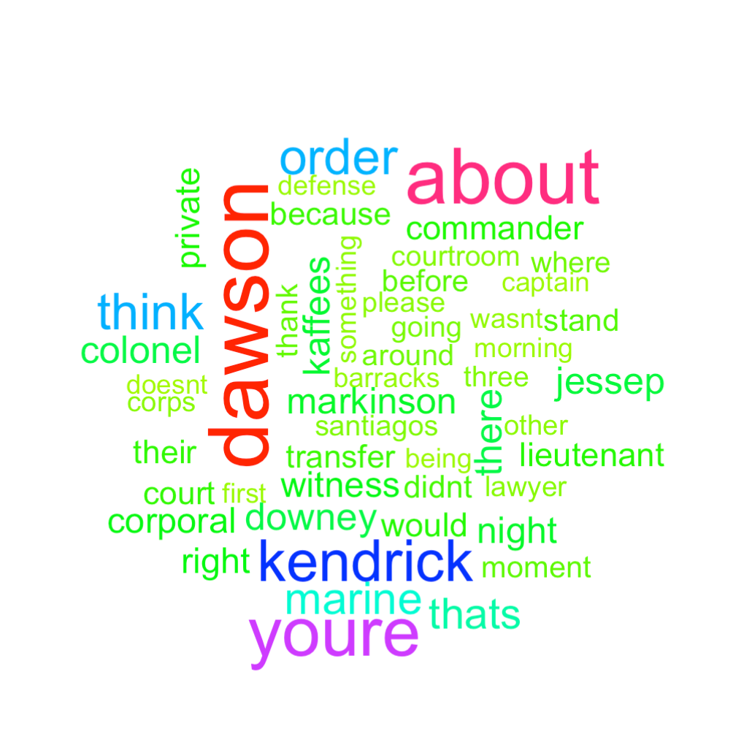

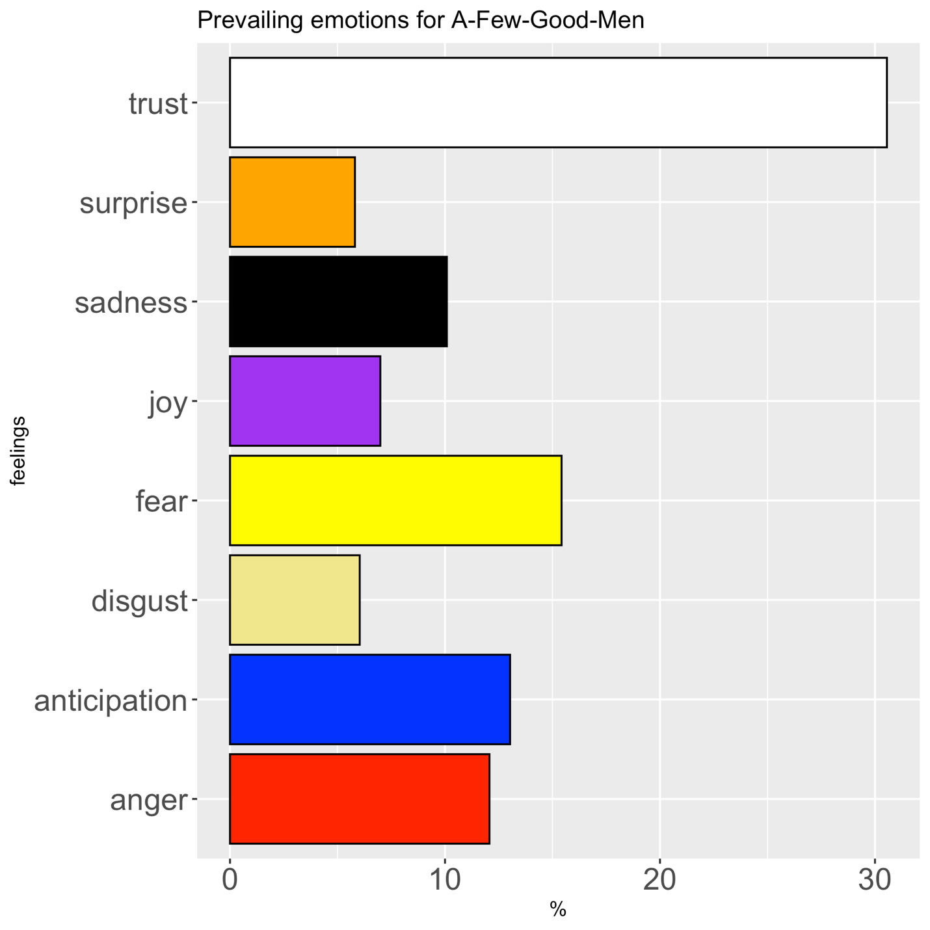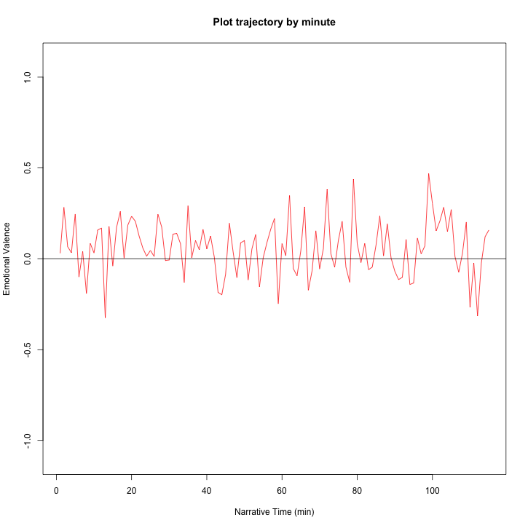

The plot trajectory shows an overall positive sentiment throughout the film.

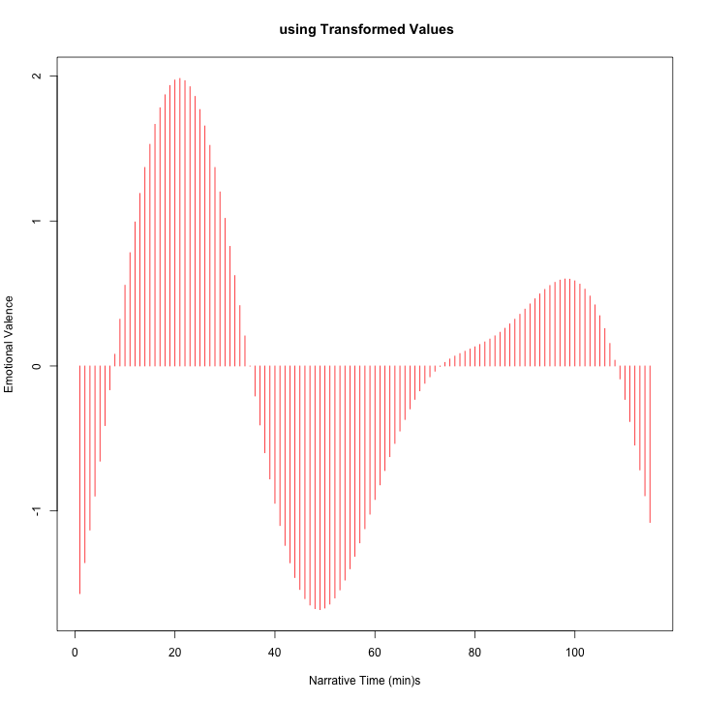

A few good man ends on a slightly negative sentiment and that is reflected here.

**Movie #2 A Prayer Before Dawn**

#First 20 most frequent words for Movie#2  
word.freq_2 = sort(rowSums(tdm.mat_2), decreasing = T)  
barplot(word.freq_2[4:20], cex.names = .8)

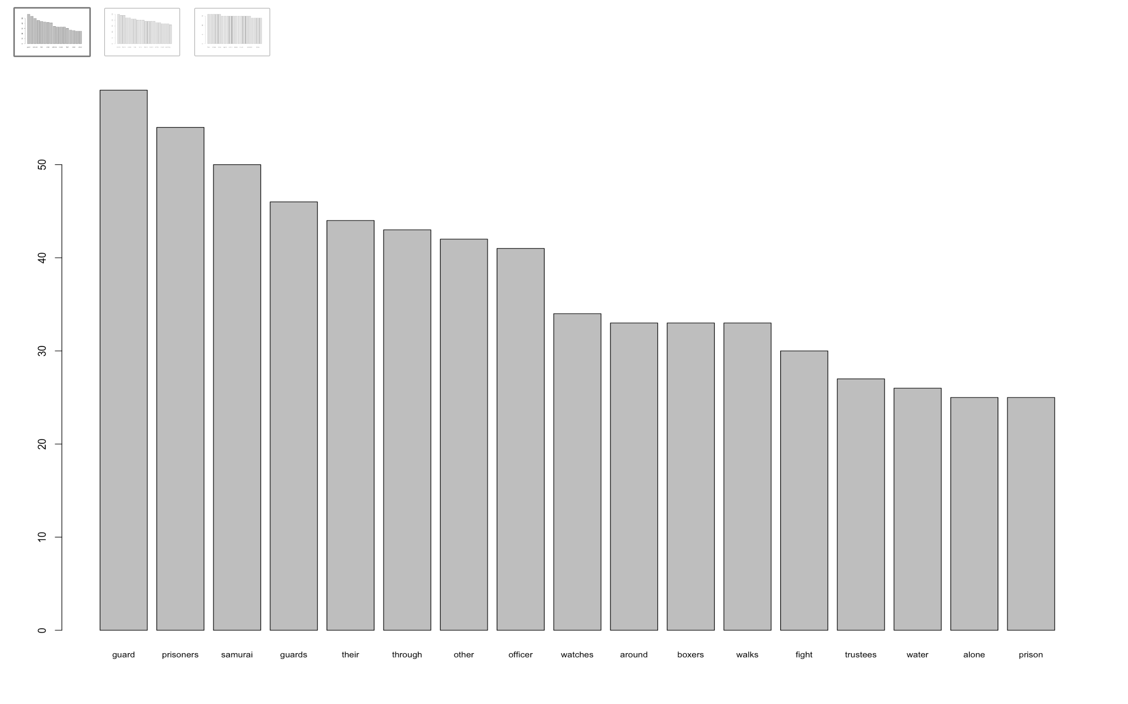

#Next 20 most frequent words  
barplot(word.freq_2[21:40], cex.names = .8)

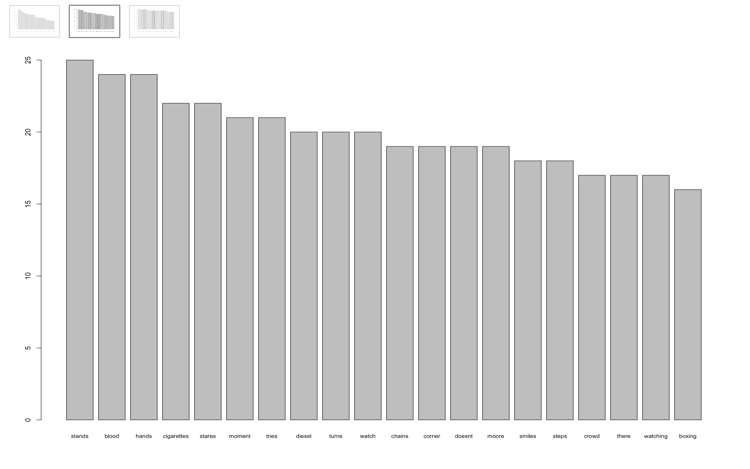

#Next 20 most frequent words  
barplot(word.freq_2[41:60], cex.names = .8)

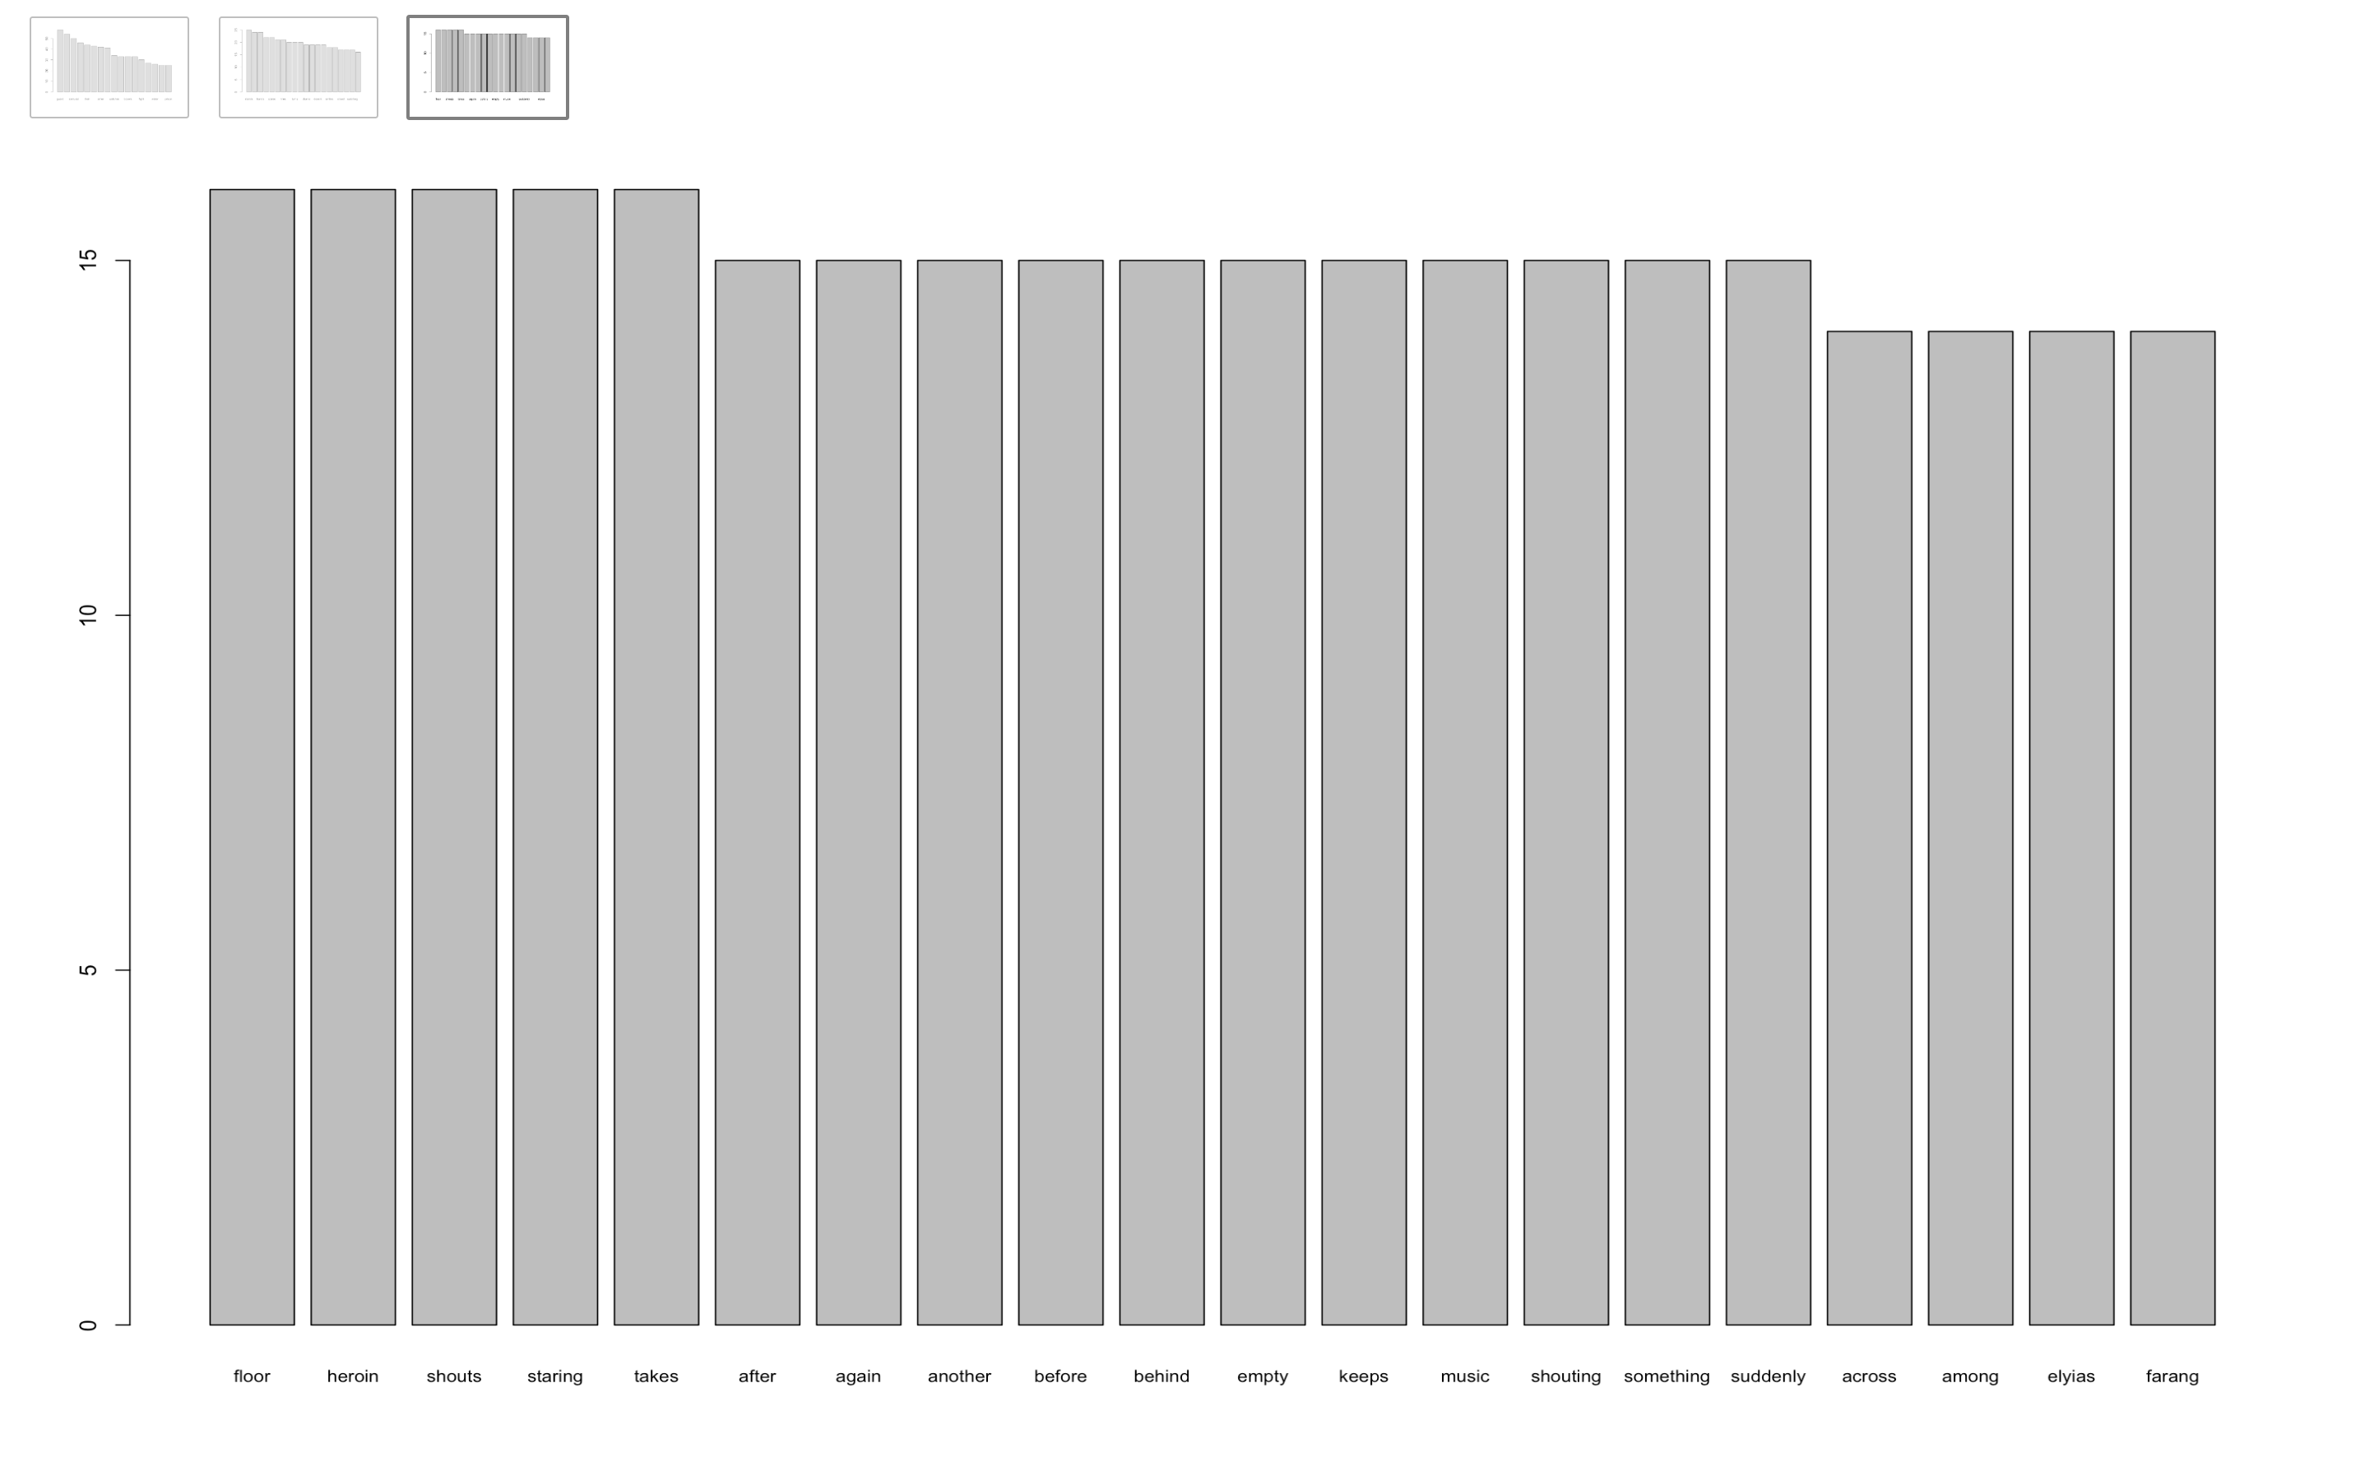

dim(tdm.mat_2)

## [1] 2544 1

#Word Cloud for Movie#2  
#wordcloud(words = names(word.freq_2[4:2544]), freq = word.freq_check, min.freq = 100, col = rainbow(1000), max.words = 50)

**Movie #2 A Prayer Before Dawn**

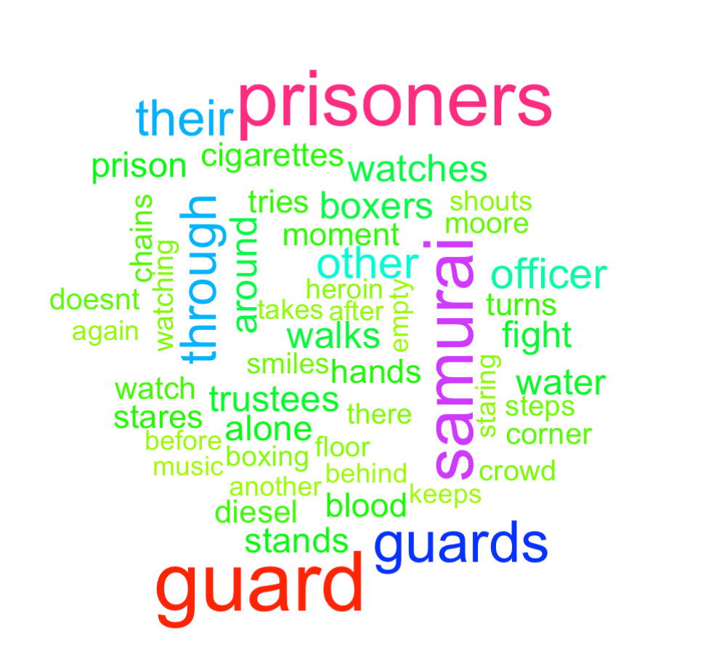

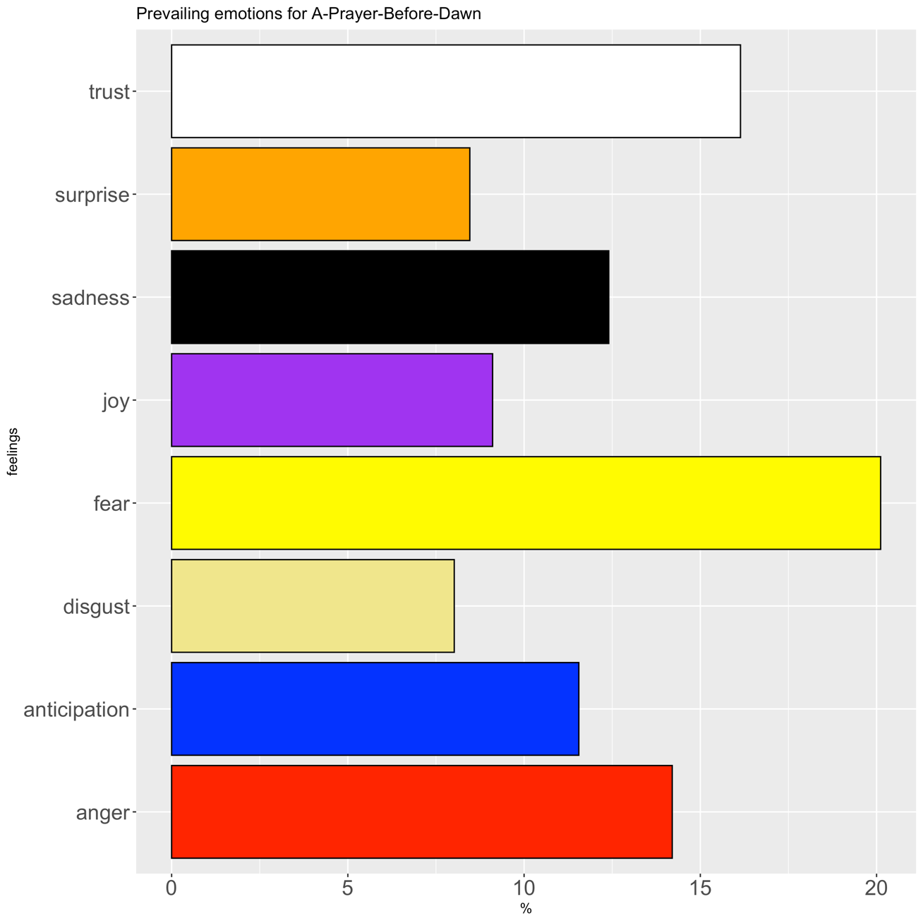

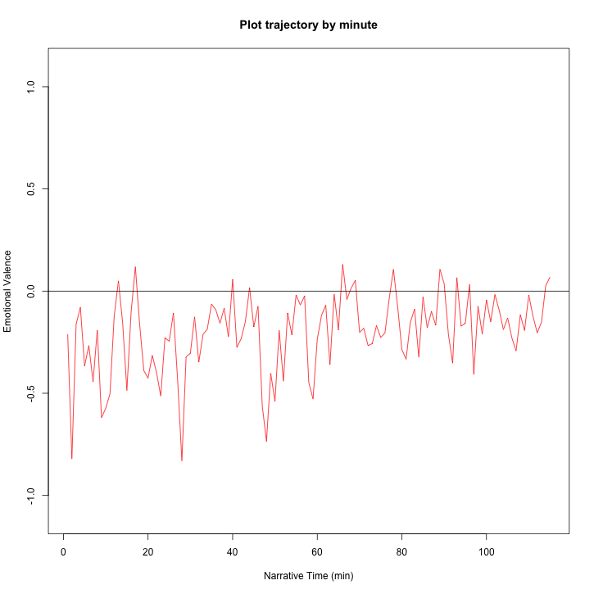

When looking at line by line of A Prayer by Dawn we can see that the overall sentiment is negative throughout the film.

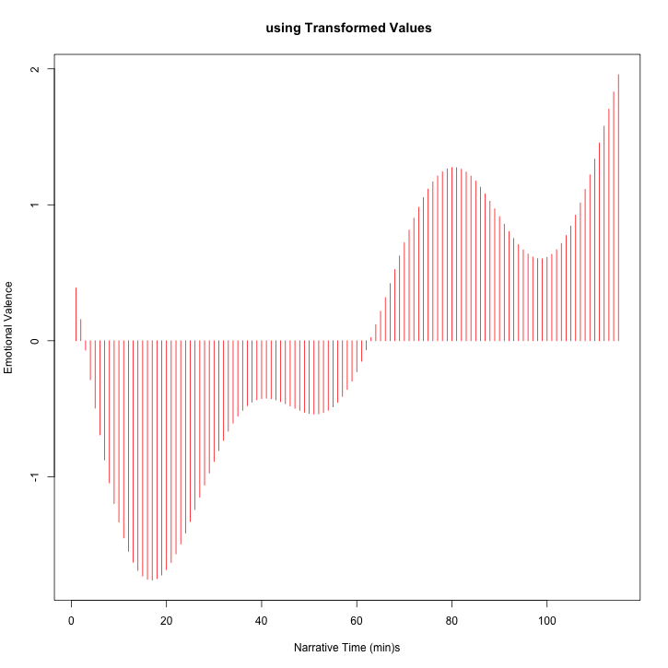

A Prayer Before Dawn starts out as a really negative movie and then eventually has a positive emotional variance.